

Capstone Project Report
Report 3 – Software Requirement Specification

PickleVerse – Multiplayer Pickleball Skill-Training and Match Game with AI Coaching

Project code: PKV Group: GFA26SE111
Supervisor: Mr. Lại Đức Hùng
Team: Huỳnh Trung Kiên (Leader), Nguyễn Văn Thành Đạt,
Nguyễn Gia Huy, Trần Nguyễn Hiếu Thuận

– Ho Chi Minh City, November 2026 –
Table of Contents
I. Record of Changes 3
II. Software Requirement Specification 3
1. Product Overview 3
2. User Requirements 4
2.1 Actors 4
2.2 Use Cases 5
3. Functional Requirements 17
3.1 System Functional Overview 17
3.2 Account and Onboarding (FE-01) 26
3.3 Tutorial and Technique Training (FE-02) 33
3.4 Core Gameplay and Bot Practice (FE-03) 39
3.5 Online Matches (FE-04) 42
3.6 AI Coaching (FE-05) 46
3.7 Progress, Rewards and Shop (FE-06) 47
3.8 Social, History and Ranking (FE-07) 50
3.9 Reports, Restrictions and Appeals (FE-08) 53
3.10 Administration Web Application (FE-09) 54
3.11 Expert Review (FE-10) 58
4. Non-Functional Requirements 58
4.1 External Interfaces 58
4.2 Quality Attributes 59
5. Requirement Appendix 61
5.1 Business Rules 61
5.2 Common Requirements 63
5.3 Application Messages List 63
5.4 Definitions and Acronyms 65
5.5 Appendix A – Traceability to the Review 2 Commitment 65
5.6 References 66

I. Record of Changes
Date | A*  M, D | In charge | Change Description
27/10/2026 | A | Nguyễn Gia Huy | v0.1 – Feature list F01–F18, actors and workflows prepared for the Review 2 commitment (BM04).
06/11/2026 | A | Nguyễn Văn Thành Đạt | v0.2 – First SRS on the official template: 23 use cases, FR-01 to FR-23, 10 NFRs.
07/11/2026 | M | Nguyễn Văn Thành Đạt | v0.3 – Linked the Review 2 feature list to the requirements; added business rules and API messages.
11/11/2026 | M | Nguyễn Gia Huy | v1.0 – Rewritten after the internal review: corrected context diagram; six actors; 68 use cases in eight UML use case diagrams; screen flows from the real scenes; screen authorization matrix; conceptual ERD; 33 functional requirements with real screenshots, data fields, validation and exception flows; gameplay, economy and authentication rules; measurable NFRs; message list in the product language.
*A - Added M - Modified D - Deleted

II. Software Requirement Specification

1. Product Overview
PickleVerse is a new 3D pickleball game that teaches beginners the rules and core techniques of pickleball and lets them practise against bots and other players online. Release 1.0 consists of five deployable parts that together form the system under specification: the Unity game client for Windows and Android, the Unity dedicated game server that runs online matches with server authority, the ASP.NET Core Web API with its PostgreSQL database and Redis cache, the Python AI coaching service, and the React administration web application. The Web API hosts the background workers for matchmaking, dedicated-server leases, AI analysis and moderation expiry.
Figure 1 shows the context of release 1.0. The system exchanges data with two human actors and three external systems. Photon Cloud provides the real-time session and relay service used by the game client and the dedicated server; Gmail SMTP delivers one-time passwords; S3-compatible object storage keeps match replays. Real-money payment, social login and push notifications are outside the boundary of this release.
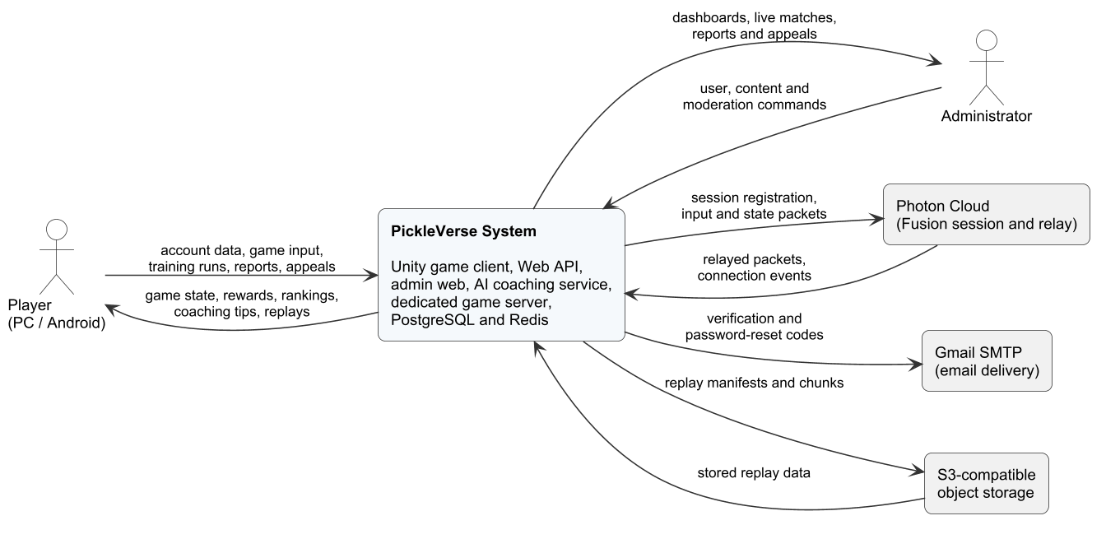
Figure 1. Context diagram of PickleVerse release 1.0
Table 1. External entities of the context diagram
External entity | Type | Data exchanged with PickleVerse
Player | Human (Windows PC or Android phone) | Sends account data, game input, training attempts, reports and appeals; receives game state, rewards, rankings, coaching tips and replays
Administrator | Human (web browser) | Sends user, content, match and moderation commands; receives dashboards, live match status, reports, appeals and analytics
Photon Cloud | External real-time service | Receives session registration and input/state packets from the client and the dedicated server; returns relayed packets and connection events
Gmail SMTP | External e-mail service | Receives verification and password-reset messages to deliver to the player's mailbox
S3-compatible object storage | Storage service | Stores replay manifests and compressed replay chunks; returns them for the replay viewer and moderation

2. User Requirements

2.1 Actors
Table 2. Actors
# | Actor | Description
1 | Visitor | A person who uses the game client without being signed in. A visitor can register, verify an e-mail address, sign in, reset a forgotten password and, on a device that has a cached profile, start offline training.
2 | Player | A signed-in user with the Player role and an active account. A player inherits every use case of a visitor and can learn, train, play bot and online matches, view progress, use the shop and the social features, and report other players.
3 | Restricted Player | A player whose account is suspended or banned. After signing in, a restricted player is limited to viewing the sanction decision and submitting one appeal for it.
4 | Administrator | A user with the Admin role who signs in to the administration web application to manage accounts, content, matches, moderation and analytics, and to label coaching sessions as an expert reviewer.
5 | Email Service | Secondary actor (Gmail SMTP) that delivers verification and password-reset codes.
6 | Photon Cloud | Secondary actor that hosts the real-time sessions through which the game client, other players and the dedicated server exchange match packets.

2.2 Use Cases

2.2.1 Diagram(s)
The 68 use cases are grouped into eight packages. Figure 2 gives the package overview; Figures 3 to 11 show each package with its actors and the «include» and «extend» relationships (package P4 is drawn in two parts for readability). Player and Restricted Player are specialisations of Visitor, so they inherit the visitor use cases.
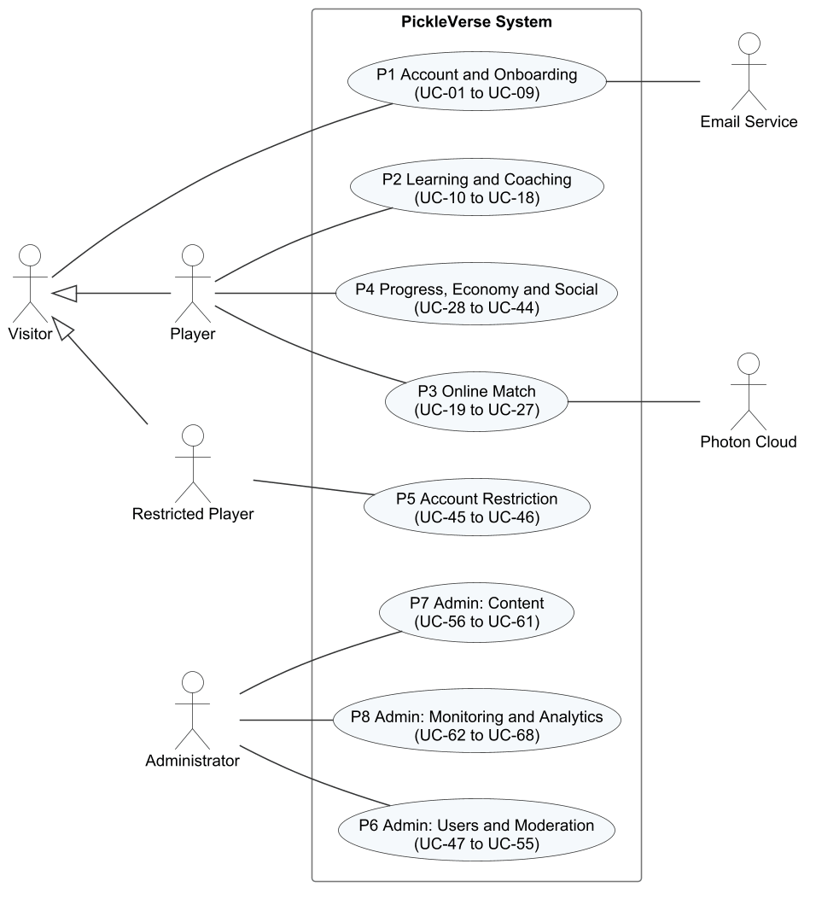
Figure 2. Use case overview by package
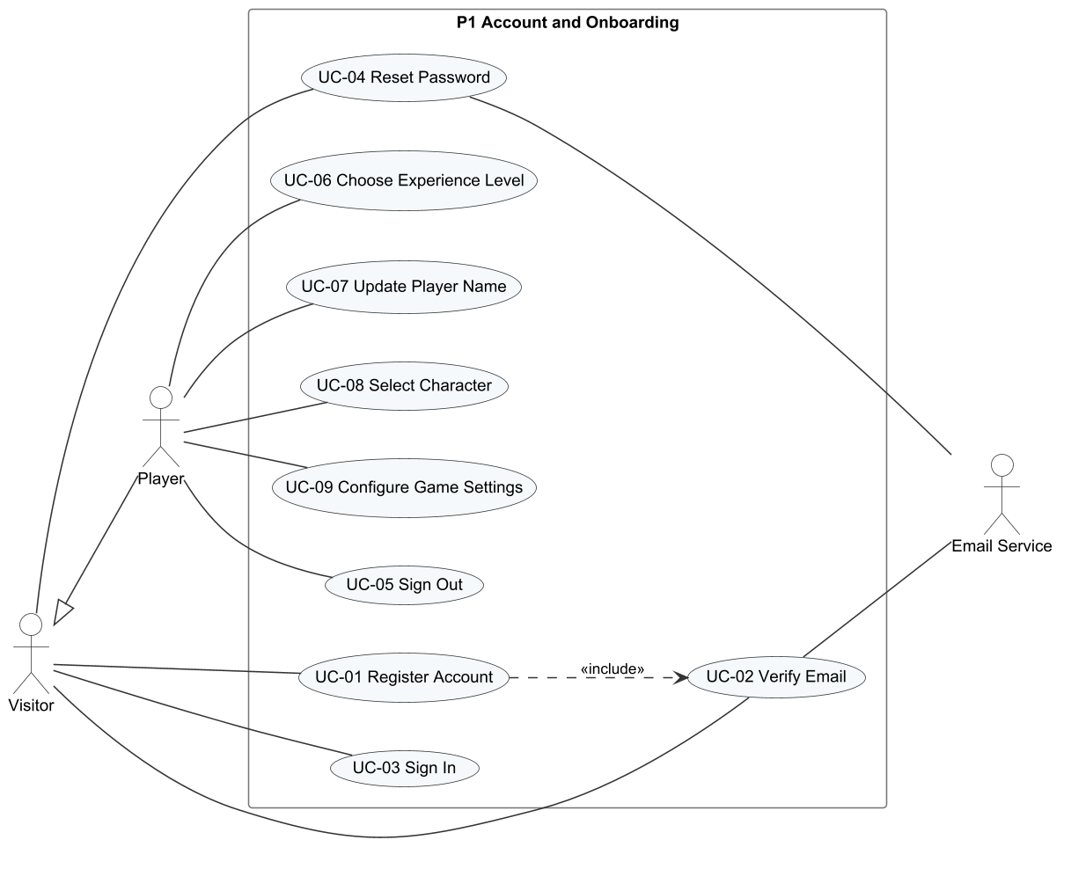
Figure 3. Use case diagram P1 – Account and Onboarding
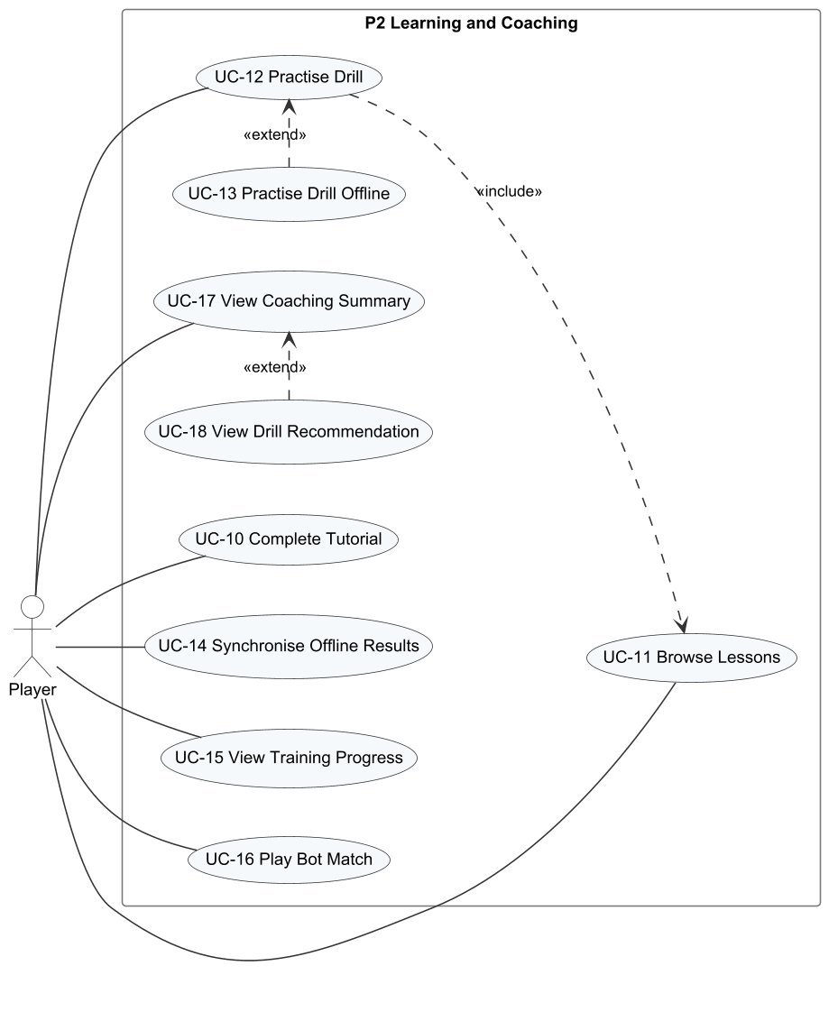
Figure 4. Use case diagram P2 – Learning and Coaching
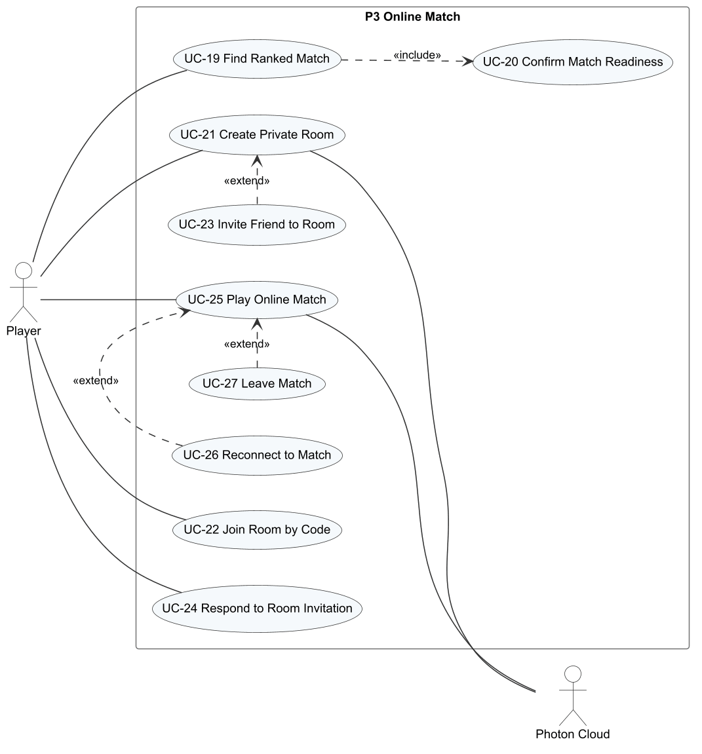
Figure 5. Use case diagram P3 – Online Match
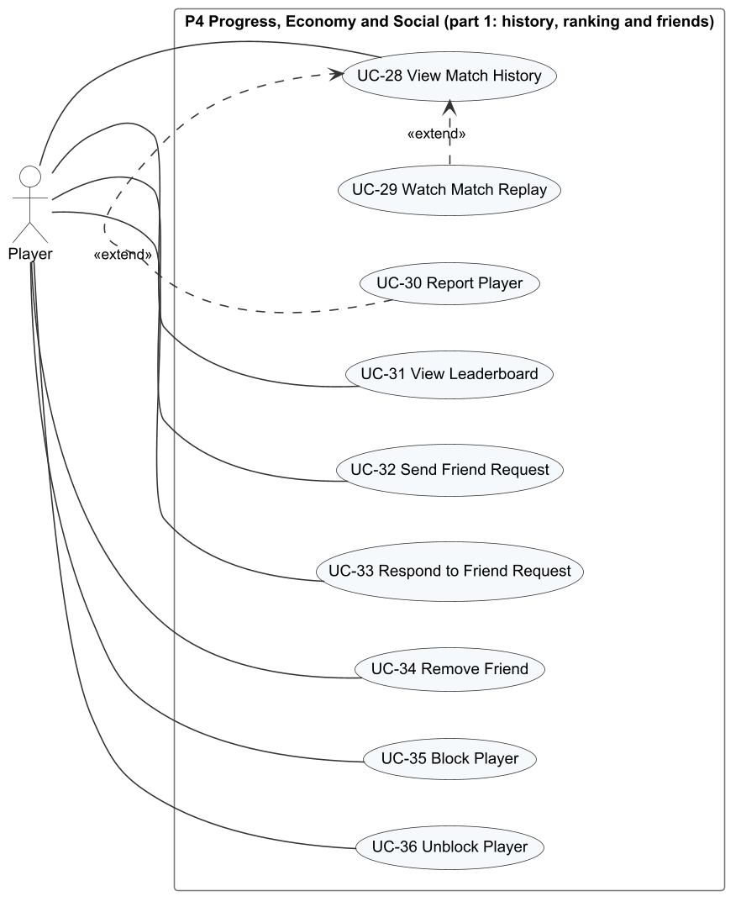
Figure 6. Use case diagram P4 (part 1) – History, Ranking and Friends
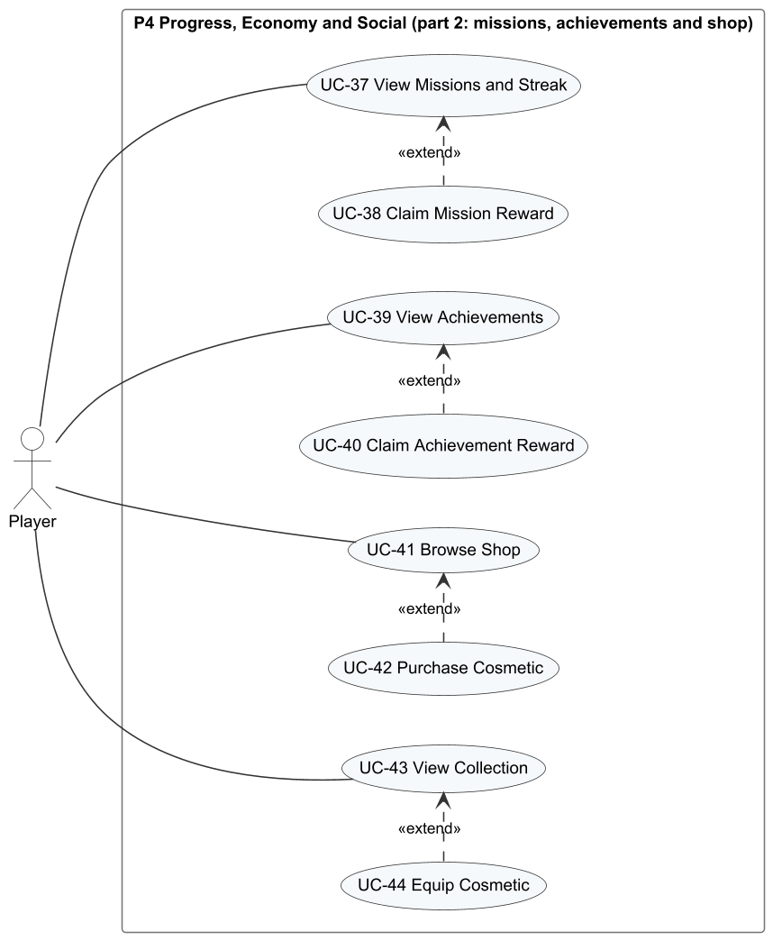
Figure 7. Use case diagram P4 (part 2) – Missions, Achievements and Shop
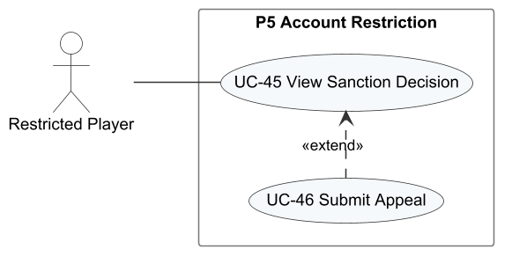
Figure 8. Use case diagram P5 – Account Restriction
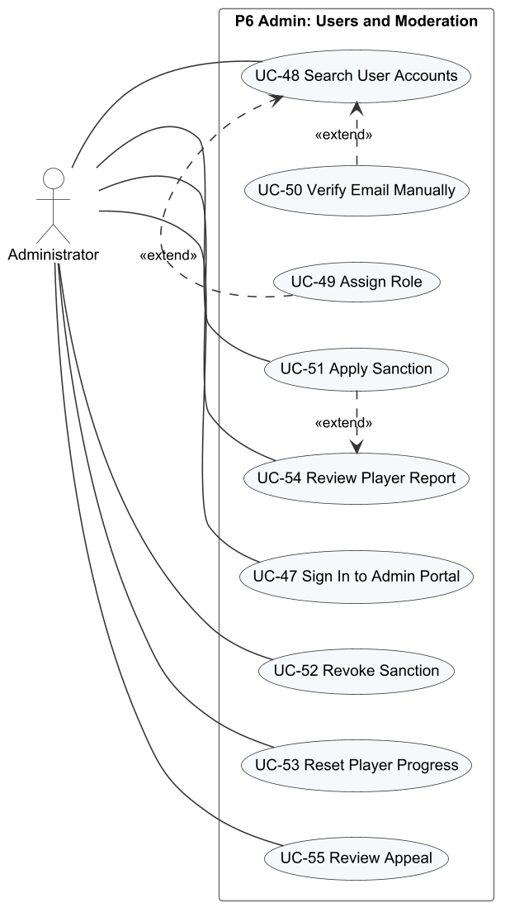
Figure 9. Use case diagram P6 – Admin: Users and Moderation
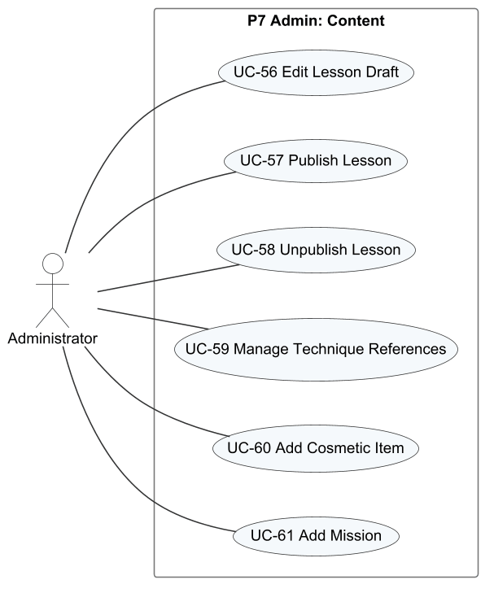
Figure 10. Use case diagram P7 – Admin: Content
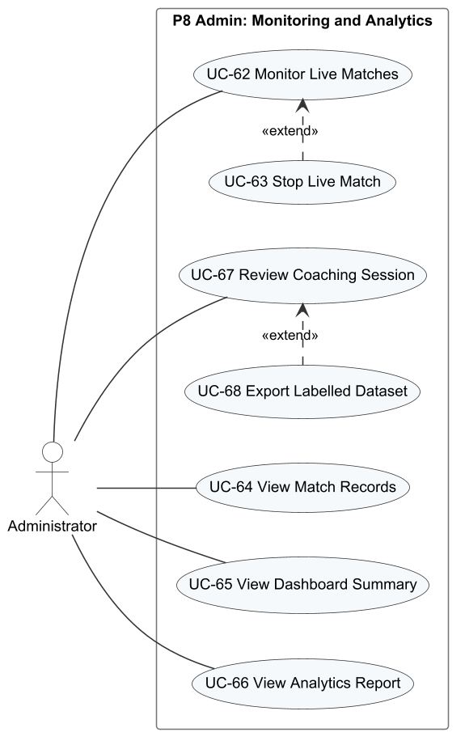
Figure 11. Use case diagram P8 – Admin: Monitoring and Analytics

2.2.2 Descriptions
Table 3. Use case descriptions
ID | Use Case | Actors | Use Case Description | FR
UC-01 | Register Account | Visitor | The visitor creates an account with an e-mail address and a password; the system sends a six-digit code to that address. | FR-01
UC-02 | Verify Email | Visitor, Email Service | The visitor enters the code received by e-mail to activate the account, or asks for a new code. | FR-01
UC-03 | Sign In | Visitor | The visitor signs in with e-mail and password and is taken to the menu with the saved profile. | FR-02
UC-04 | Reset Password | Visitor, Email Service | The visitor receives a reset code by e-mail and sets a new password; all existing sessions are revoked. | FR-03
UC-05 | Sign Out | Player | The player ends the session on the device. | FR-02
UC-06 | Choose Experience Level | Player | At the first sign-in the player states whether they are new to pickleball, which decides whether the tutorial starts. | FR-04
UC-07 | Update Player Name | Player | The player changes the display name shown to other players. | FR-04
UC-08 | Select Character | Player | The player chooses the male or female character used in matches. | FR-04
UC-09 | Configure Game Settings | Player | The player adjusts audio, graphics, key bindings and the touch layout. | FR-05
UC-10 | Complete Tutorial | Player | The player follows the 17-step tutorial on the court, rules and controls. | FR-06
UC-11 | Browse Lessons | Player | The player views the lesson catalogue by group, with stars and lock status. | FR-07
UC-12 | Practise Drill | Player | The player plays the drill of an unlocked lesson and receives a score of 0 to 3 stars. | FR-08
UC-13 | Practise Drill Offline | Player | Without a connection, the player practises a cached drill; the result is stored for later synchronisation. | FR-09
UC-14 | Synchronise Offline Results | Player | When online again, the stored offline results are sent and applied exactly once. | FR-09
UC-15 | View Training Progress | Player | The player reviews passed lessons, practice time, common errors and post-session feedback. | FR-10
UC-16 | Play Bot Match | Player | The player configures and plays a singles match against a computer opponent. | FR-11, FR-12, FR-13
UC-17 | View Coaching Summary | Player | After a drill or match the player reads the analysis of their shots and the main errors. | FR-19
UC-18 | View Drill Recommendation | Player | The player opens a recommended drill that targets a detected weakness. | FR-19
UC-19 | Find Ranked Match | Player | The player joins the ranked singles queue and is paired with an opponent of similar Elo, or with a bot after 180 seconds. | FR-14
UC-20 | Confirm Match Readiness | Player | Each paired player accepts the match within 10 seconds before it starts. | FR-14
UC-21 | Create Private Room | Player, Photon Cloud | The player creates a singles or doubles room identified by a room code. | FR-15
UC-22 | Join Room by Code | Player | The player joins a friend's room by typing its code. | FR-15
UC-23 | Invite Friend to Room | Player | The host invites an online friend into the room. | FR-15
UC-24 | Respond to Room Invitation | Player | The invited player accepts or declines the invitation. | FR-15
UC-25 | Play Online Match | Player, Photon Cloud | The players play a match whose rules and score are decided by the dedicated server. | FR-16
UC-26 | Reconnect to Match | Player | After a disconnection the player rejoins the same match within the reconnection window. | FR-17
UC-27 | Leave Match | Player | The player leaves a match before it ends and accepts the consequences. | FR-17
UC-28 | View Match History | Player | The player views the last 20 matches with result, score and Elo change. | FR-24
UC-29 | Watch Match Replay | Player | The player watches the replay of one of their own matches with pause, seek and speed control. | FR-24
UC-30 | Report Player | Player | The player reports an opponent from a finished match with a reason. | FR-27
UC-31 | View Leaderboard | Player | The player views players ordered by Elo and their own position. | FR-26
UC-32 | Send Friend Request | Player | The player searches by name or ID and sends a friend request. | FR-25
UC-33 | Respond to Friend Request | Player | The player accepts or declines a received request. | FR-25
UC-34 | Remove Friend | Player | The player removes a friend from the friend list. | FR-25
UC-35 | Block Player | Player | The player blocks another player, which removes friendship and prevents requests and invitations. | FR-25
UC-36 | Unblock Player | Player | The player removes a block. | FR-25
UC-37 | View Missions and Streak | Player | The player views daily and weekly missions, their progress and the daily streak. | FR-21
UC-38 | Claim Mission Reward | Player | The player claims the reward of a completed mission or mission set once. | FR-21
UC-39 | View Achievements | Player | The player views achievement progress. | FR-21
UC-40 | Claim Achievement Reward | Player | The player claims the reward of a completed achievement once. | FR-21
UC-41 | Browse Shop | Player | The player views cosmetic items with their prices and currencies. | FR-22
UC-42 | Purchase Cosmetic | Player | The player buys an item with in-game currency. | FR-22
UC-43 | View Collection | Player | The player views owned cosmetic items. | FR-23
UC-44 | Equip Cosmetic | Player | The player equips an owned paddle, which is then shown in matches. | FR-23
UC-45 | View Sanction Decision | Restricted Player | The restricted player reads the restriction type, reason and expiry. | FR-28
UC-46 | Submit Appeal | Restricted Player | The restricted player submits one written appeal against a sanction. | FR-28
UC-47 | Sign In to Admin Portal | Administrator | The administrator signs in to the web application; only the Admin role is accepted. | FR-29
UC-48 | Search User Accounts | Administrator | The administrator searches and filters accounts by text and status. | FR-29
UC-49 | Assign Role | Administrator | The administrator changes the role of an account between Player and Admin. | FR-29
UC-50 | Verify Email Manually | Administrator | The administrator activates an account whose verification e-mail could not be delivered. | FR-29
UC-51 | Apply Sanction | Administrator | The administrator suspends or bans an account with a reason, optionally from a report. | FR-29, FR-30
UC-52 | Revoke Sanction | Administrator | The administrator lifts an active sanction with a reason. | FR-29
UC-53 | Reset Player Progress | Administrator | The administrator previews and resets selected progress groups of a player. | FR-29
UC-54 | Review Player Report | Administrator | The administrator examines a report with match evidence and accepts or declines it. | FR-30
UC-55 | Review Appeal | Administrator | The administrator accepts or declines an appeal; acceptance revokes the related sanction. | FR-30
UC-56 | Edit Lesson Draft | Administrator | The administrator creates or edits a lesson and saves it as a draft. | FR-31
UC-57 | Publish Lesson | Administrator | The administrator publishes the saved draft so that new attempts use it. | FR-31
UC-58 | Unpublish Lesson | Administrator | The administrator hides a published lesson from players. | FR-31
UC-59 | Manage Technique References | Administrator | The administrator maintains the reference values used to judge each technique. | FR-31
UC-60 | Add Cosmetic Item | Administrator | The administrator adds an item to the shop with type, price and currency. | FR-31
UC-61 | Add Mission | Administrator | The administrator creates a daily or weekly mission with target and reward. | FR-31
UC-62 | Monitor Live Matches | Administrator | The administrator watches active matches with score and connection status refreshed every 5 seconds. | FR-32
UC-63 | Stop Live Match | Administrator | The administrator stops a dedicated-server match with a reason. | FR-32
UC-64 | View Match Records | Administrator | The administrator browses finished and interrupted matches. | FR-32
UC-65 | View Dashboard Summary | Administrator | The administrator sees today's key figures and items that need action. | FR-32
UC-66 | View Analytics Report | Administrator | The administrator views active users, retention, lesson pass rates, technique errors and matchmaking health for a date range. | FR-32
UC-67 | Review Coaching Session | Administrator | Acting as expert, the administrator inspects shot evidence of a training session and labels the player level and errors. | FR-33
UC-68 | Export Labelled Dataset | Administrator | The administrator exports the labelled sessions used to evaluate the AI coaching quality. | FR-33

3. Functional Requirements

3.1 System Functional Overview

3.1.1 Screens Flow
Figure 12 shows the screens of the game client and how a player moves between them; Figure 13 shows the administration web application. Rounded white boxes marked [popup], [dialog], [drawer] or [overlay] are windows opened above another screen; the other boxes are full scenes or pages.
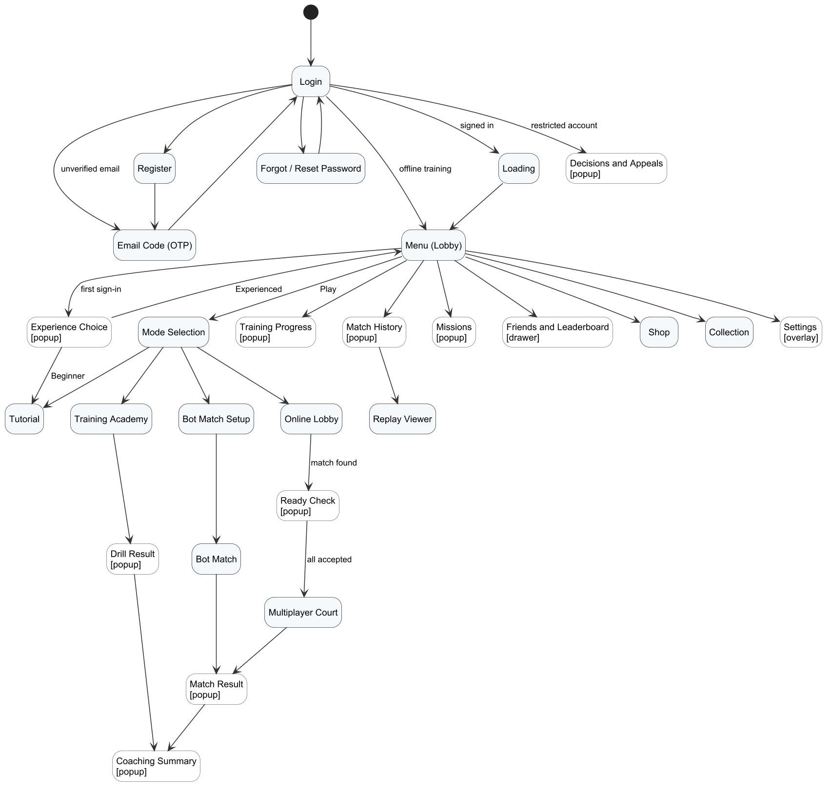
Figure 12. Screen flow of the game client
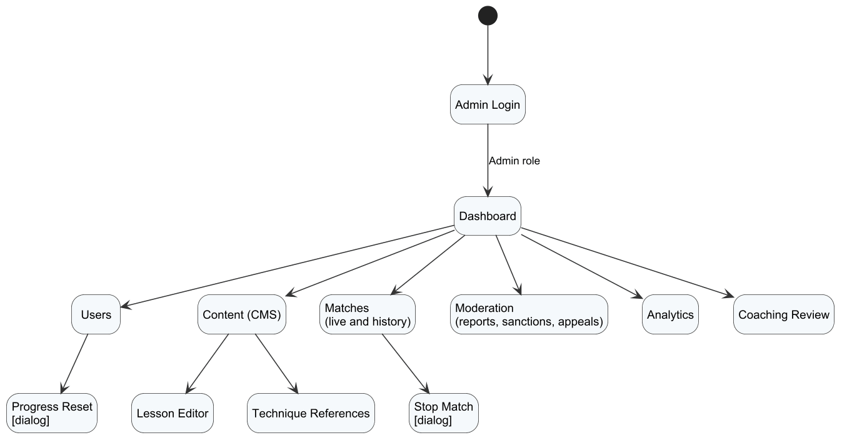
Figure 13. Screen flow of the administration web application

3.1.2 Screen Descriptions
Table 4. Screen descriptions
# | Feature | Screen | Description
1 | FE-01 | Login | E-mail and password fields with a show/hide control, the Sign in button, links to e-mail verification, password recovery and registration, and an Offline training button when a profile is cached on the device.
2 | FE-01 | Register | E-mail, password and password confirmation fields with inline validation and the Create account button.
3 | FE-01 | Email Verification (OTP) | Six-digit code field, Verify and Resend code buttons, and a link back to sign-in.
4 | FE-01 | Forgot / Reset Password | Step 1 asks for the e-mail address; step 2 asks for the reset code, the new password and its confirmation.
5 | FE-01 | Loading | Animated artwork while the profile, wallet, content catalogue and settings are loaded.
6 | FE-01 | Experience Choice [popup] | Asked once at the first sign-in: "Bạn đã quen với pickleball chưa?" with Beginner and Experienced options.
7 | FE-01 | Menu (Lobby) | 3D court with the player's character; name tag with level, rank and Elo; Tokenpad and Elite Token balances; male/female selector; music player; Play button; buttons for Progress, History, Missions, Collection, Shop and Settings; friend drawer; Decisions and Appeals button.
8 | FE-01 | Settings [overlay] | Tabs Overview (with Sign out), Audio, Graphics and Controls (key binding and touch layout); Restore defaults, Undo and Apply and save buttons.
9 | FE-02 | Tutorial | Seventeen steps on the court; each step has a title, an explanation and a demonstration, with Continue, Replay and Later buttons.
10 | FE-02 | Mode Selection | Four cards – Bot match, Online match, Training and Create room – and a Tutorial strip.
11 | FE-02 | Training Academy | Lesson catalogue with group tabs (All, Basic, Control, Advanced, Doubles); lesson briefing with target, reward and star rules; practice HUD with shot counter, timing feedback and key hints.
12 | FE-02 | Drill Result [popup] | Stars, accuracy (hits in target / shots), mean timing error, practice time, most frequent error with a tip, and Retry, Next lesson and Lesson list buttons.
13 | FE-02 | Training Progress [popup] | Passed lessons out of 15, next lesson, post-session feedback, practice time, most frequent error, and per-lesson best result with a Retry button.
14 | FE-03 | Bot Match Setup | Difficulty (Easy, Medium, Hard, Adaptive), time of day (day, night) and court (professional, outdoor), with a summary line and the Enter court button.
15 | FE-03 | Bot Match | Court with both players, score and serving side, serve timer, fault banners, time-out control, key hints and the pause/settings overlay.
16 | FE-03 | Match Result [popup] | Winner, game scores, Tokenpad and XP earned, Elo change for ranked matches, and Play again, Mode selection and View analysis buttons.
17 | FE-05 | Coaching Summary [popup] | Counts of shots, contacts and serves; main errors with their frequency; up to three recommended drills with a Practise now link.
18 | FE-04 | Online Lobby | Room code field, Join by code button, Singles 1v1 and Doubles 2v2 buttons, roster slots, friend invitation list and the Find match / Cancel button with an elapsed-time counter.
19 | FE-04 | Ready Check [popup] | Match found message with Accept and Decline buttons and a 10-second countdown.
20 | FE-04 | Multiplayer Court | Online match on the dedicated server with score, connection state, reconnecting overlay and leave control.
21 | FE-07 | Match History [popup] | Level card and the last 20 matches with opponent, mode, Vietnam time, result, game score, Elo change, and Report and Replay buttons.
22 | FE-07 | Replay Viewer | Playback of a recorded match with play/pause, a seek bar and speeds from 0.5× to 2×.
23 | FE-06 | Missions [popup] | Daily and weekly tabs, mission list with progress and reward, set bonus, daily streak, reset countdown, and Claim buttons.
24 | FE-07 | Friends and Leaderboard [drawer] | Friends tab with search by name or ID and sub-tabs Friends, Find friends and Blocked; Leaderboard tab with own position.
25 | FE-06 | Shop | Featured and all items, item preview, price in Tokenpad and/or Elite Token, wallet balances and the Buy button.
26 | FE-06 | Collection | Owned paddles with preview and the Equip button.
27 | FE-08 | Decisions and Appeals [popup] | List of sanctions on the account with type, reason and expiry; appeal form and appeal status.
28 | FE-08 | Report Player [dialog] | Opened from a history entry: reported player, match, reason field and Send button.
29 | FE-09 | Admin Login | Account or e-mail and password fields and the Authenticate button; only Admin accounts are accepted.
30 | FE-09 | Dashboard | Total users, daily active users, matches played, online time, pending reports, technique-error heat map and quick links.
31 | FE-09 | Users | Search and status filter; table of player and e-mail, role, status, Elo, play time and creation date; actions to assign a role, sanction, verify e-mail and reset progress.
32 | FE-09 | Progress Reset [dialog] | Selection of LEARNING, RANKING, MISSIONS and ECONOMY groups, an impact preview and the Reset button.
33 | FE-09 | Content (CMS) | Lesson manager (draft, publish, unpublish), drill form, shop item form, mission form and technique references.
34 | FE-09 | Matches | Live matches refreshed every 5 seconds with score and connection state, match history, and a Stop match dialog that requires a reason.
35 | FE-09 | Moderation | Reports, sanctions and appeals with match evidence and replay download, decision form and decision reason.
36 | FE-09 | Analytics | Date range in Vietnam time; daily active players, retention cohorts, popular lessons with pass rate, technique-error heat map and matchmaking health.
37 | FE-10 | Expert Review | Training sessions with shot-by-shot evidence, level and error labels, data group (training, calibration, holdout) and export.

3.1.3 Screen Authorization
X means that the role may open the screen or perform the activity. Visitor is a user who has not signed in; Restricted Player is a signed-in player with a suspended or banned account. The Web API enforces the same rules: a missing or expired token returns HTTP 401, and a valid token without the required role or scope returns HTTP 403.
Table 5. Screen authorization
Screen / Activity | Visitor | Player | Restricted Player | Administrator
Login, Register, Email Verification, Forgot Password | X
Start offline training from a cached profile | X | X
Menu, Settings, Mode Selection, Tutorial |  | X
Update name, select character, sign out |  | X
Training Academy, Drill Result, Training Progress |  | X
Bot Match Setup, Bot Match, Match Result, Coaching Summary |  | X
Online Lobby, Ready Check, Multiplayer Court |  | X
Create room, invite friend, start a custom match (host only) |  | X
Match History, Replay Viewer |  | X
Query own matches and replays only |  | X
Report a player of an own finished match |  | X
Missions, Shop, Collection |  | X
Claim rewards, purchase and equip own items |  | X
Friends and Leaderboard |  | X
Decisions and Appeals |  | X | X
Submit an appeal for an own sanction |  |  | X
Admin Login |  |  |  | X
Dashboard, Analytics |  |  |  | X
Users |  |  |  | X
Query all accounts |  |  |  | X
Assign role, verify e-mail, apply and revoke sanctions (not own account) |  |  |  | X
Preview and reset player progress |  |  |  | X
Content (CMS) |  |  |  | X
Add and update lessons, references, items and missions; publish and unpublish |  |  |  | X
Matches |  |  |  | X
Stop a live dedicated-server match |  |  |  | X
Moderation |  |  |  | X
Decide reports and appeals |  |  |  | X
Expert Review |  |  |  | X
Save expert labels and export the dataset |  |  |  | X

3.1.4 Non-Screen Functions
Table 6. Non-screen functions
# | Feature | System Function | Description
1 | FE-01 | Send verification and reset e-mails | Generates a six-digit code, stores only its HMAC, and sends the message through Gmail SMTP (STARTTLS) from a background mail queue.
2 | FE-01 | Refresh access token | Exchanges a valid refresh token for a new access token (2 hours) and a rotated refresh token (14 days); revoked or reused tokens are rejected.
3 | FE-01 | Record activity days | Records each player's login day and active day (Vietnam time) and online presence in Redis for analytics and streaks.
4 | FE-02 | Apply training results | Validates each training attempt from its telemetry, applies stars and first-pass rewards, and returns a receipt APPLIED, DUPLICATE or REJECTED for each request ID.
5 | FE-04 | Ranked matchmaking | Keeps search tickets in a Redis queue, pairs tickets within the Elo window, creates the ready check, and assigns a ranked bot after 180 seconds.
6 | FE-04 | Dedicated server allocation | Issues HMAC-signed match tickets, leases the dedicated server slot, receives heartbeats every 8 seconds and releases expired leases (DedicatedLeaseMonitor).
7 | FE-04 | Settle match result | Saves the game scores once, applies Elo for ranked matches, grants rewards and updates missions and achievements in one transaction.
8 | FE-04 | Store replay | Uploads the replay manifest and compressed chunks to object storage and links them to the match.
9 | FE-05 | Ingest telemetry | Receives shot telemetry parts from the client (or the dedicated server for online matches), stores them and creates an analysis job.
10 | FE-05 | Hybrid AI worker | Sends pending analysis jobs to the AI coaching service, stores the coaching result and retries failed jobs (HybridAiWorker).
11 | FE-05 | AI coaching service | POST /v1/analyze-session: rule-based findings, summary, at most three drill recommendations and, when the gated model is approved, a tier estimate.
12 | FE-06 | Mission cycle | Opens new daily missions at 07:00 Vietnam time each day and new weekly missions each week, and updates the daily streak.
13 | FE-07 | Leaderboard cache | Caches the Elo leaderboard in Redis for 15 seconds.
14 | FE-08 | Sanction expiry | Restores suspended accounts whose sanction has expired (ModerationExpiryWorker).
15 | FE-09 | Analytics projection | Aggregates daily active players, retention cohorts, lesson statistics and matchmaking events (AnalyticsProjectionWorker).
16 | FE-09 | Admin audit | Writes an audit record for every administrative change with actor, action, target and time.

3.1.5 Entity Relationship Diagram
The conceptual ERD is drawn in Chen notation and split into six subject areas so that every diagram stays readable. Entities are business concepts rather than database tables: junction tables appear as relationships with their own attributes (for example PARTICIPATES carries Team and Outcome), and purely technical tables such as refresh tokens and telemetry parts are omitted. The logical design of all 51 tables is given in Report 4, §2.
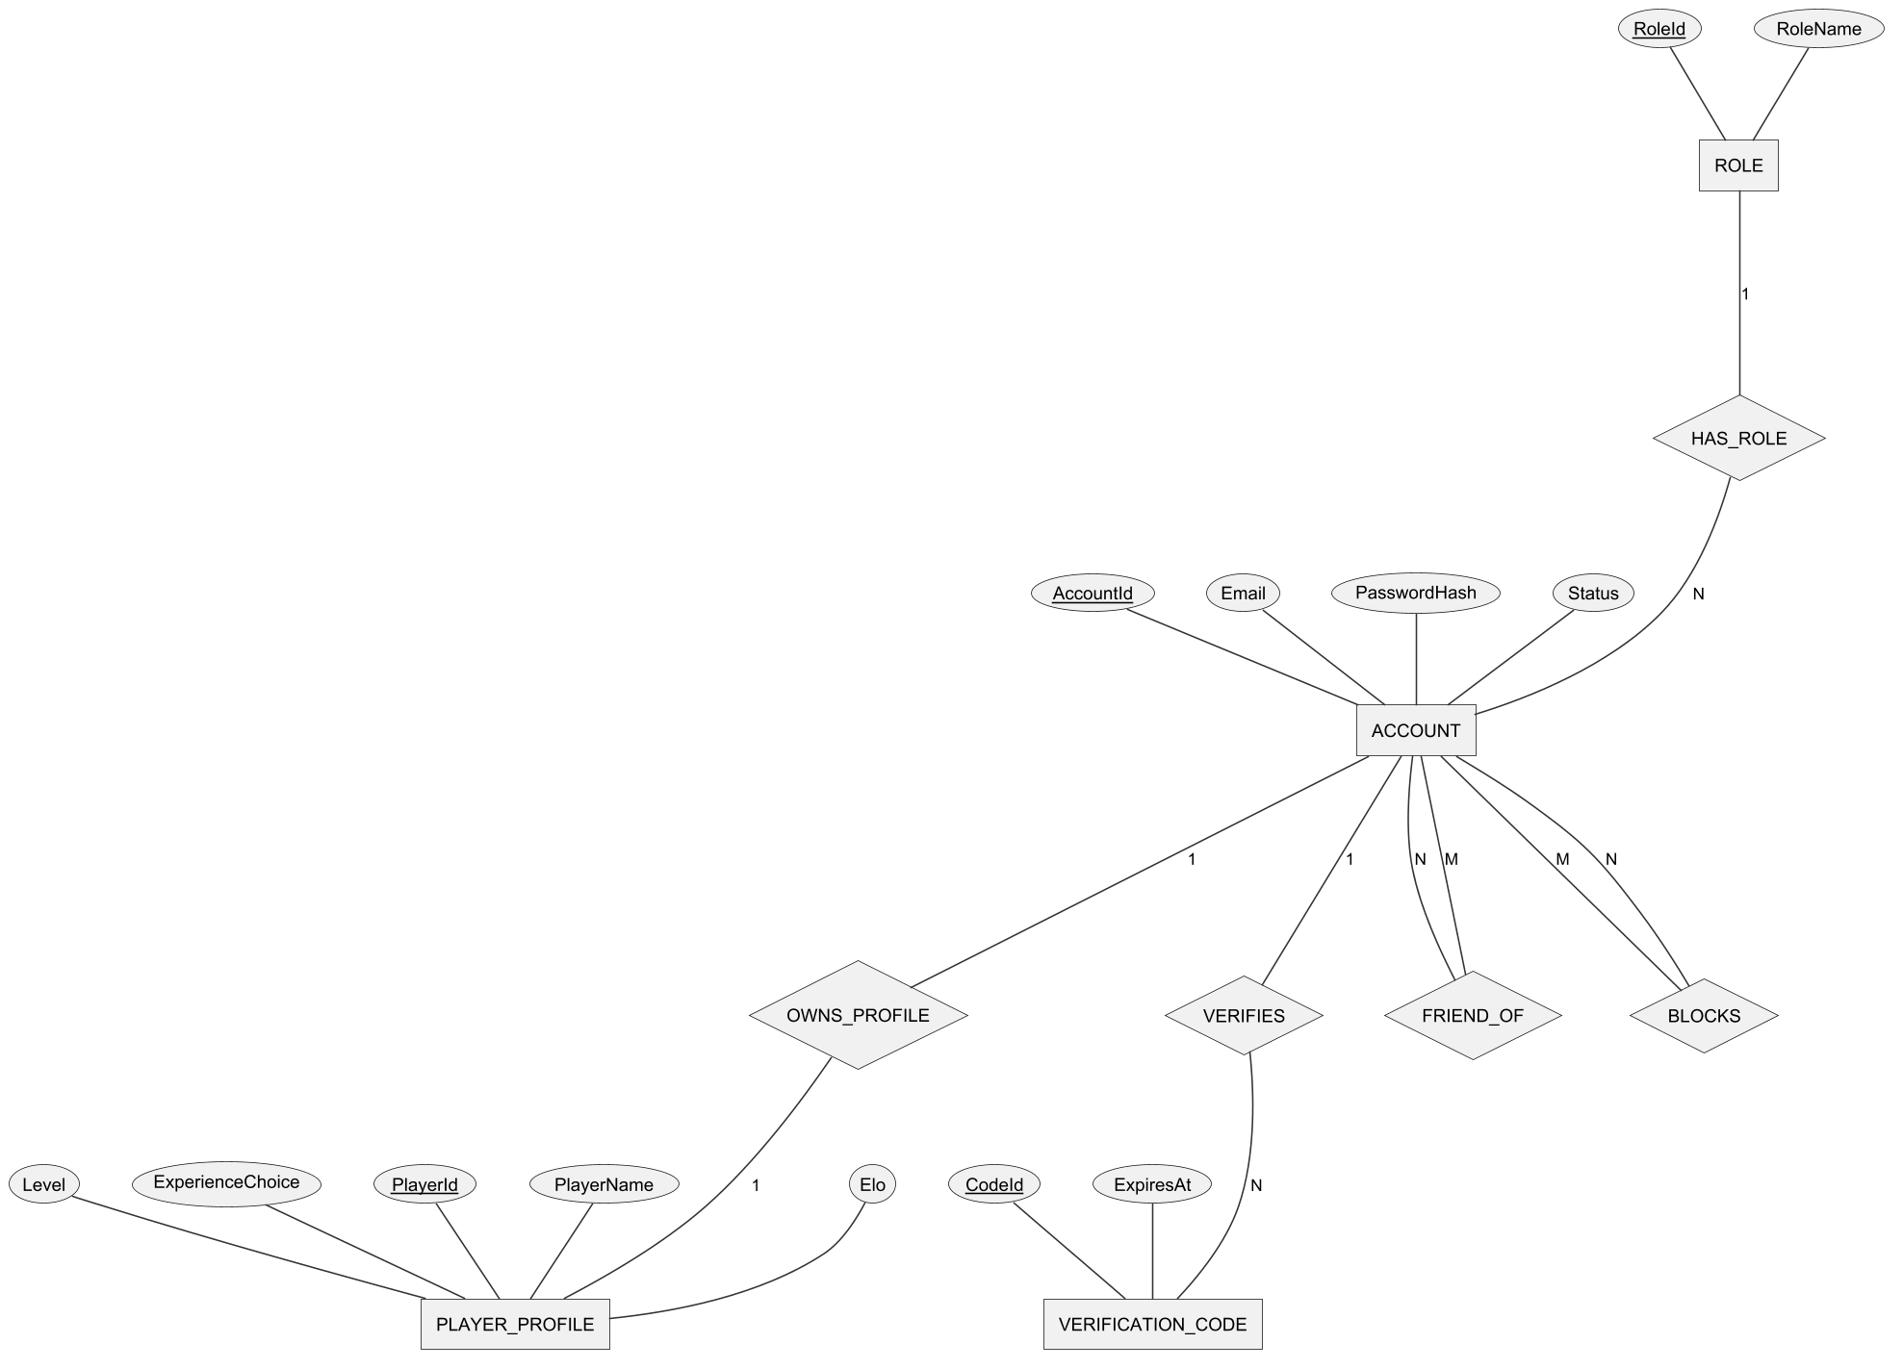
Figure 14. Conceptual ERD – accounts, profiles and social relations
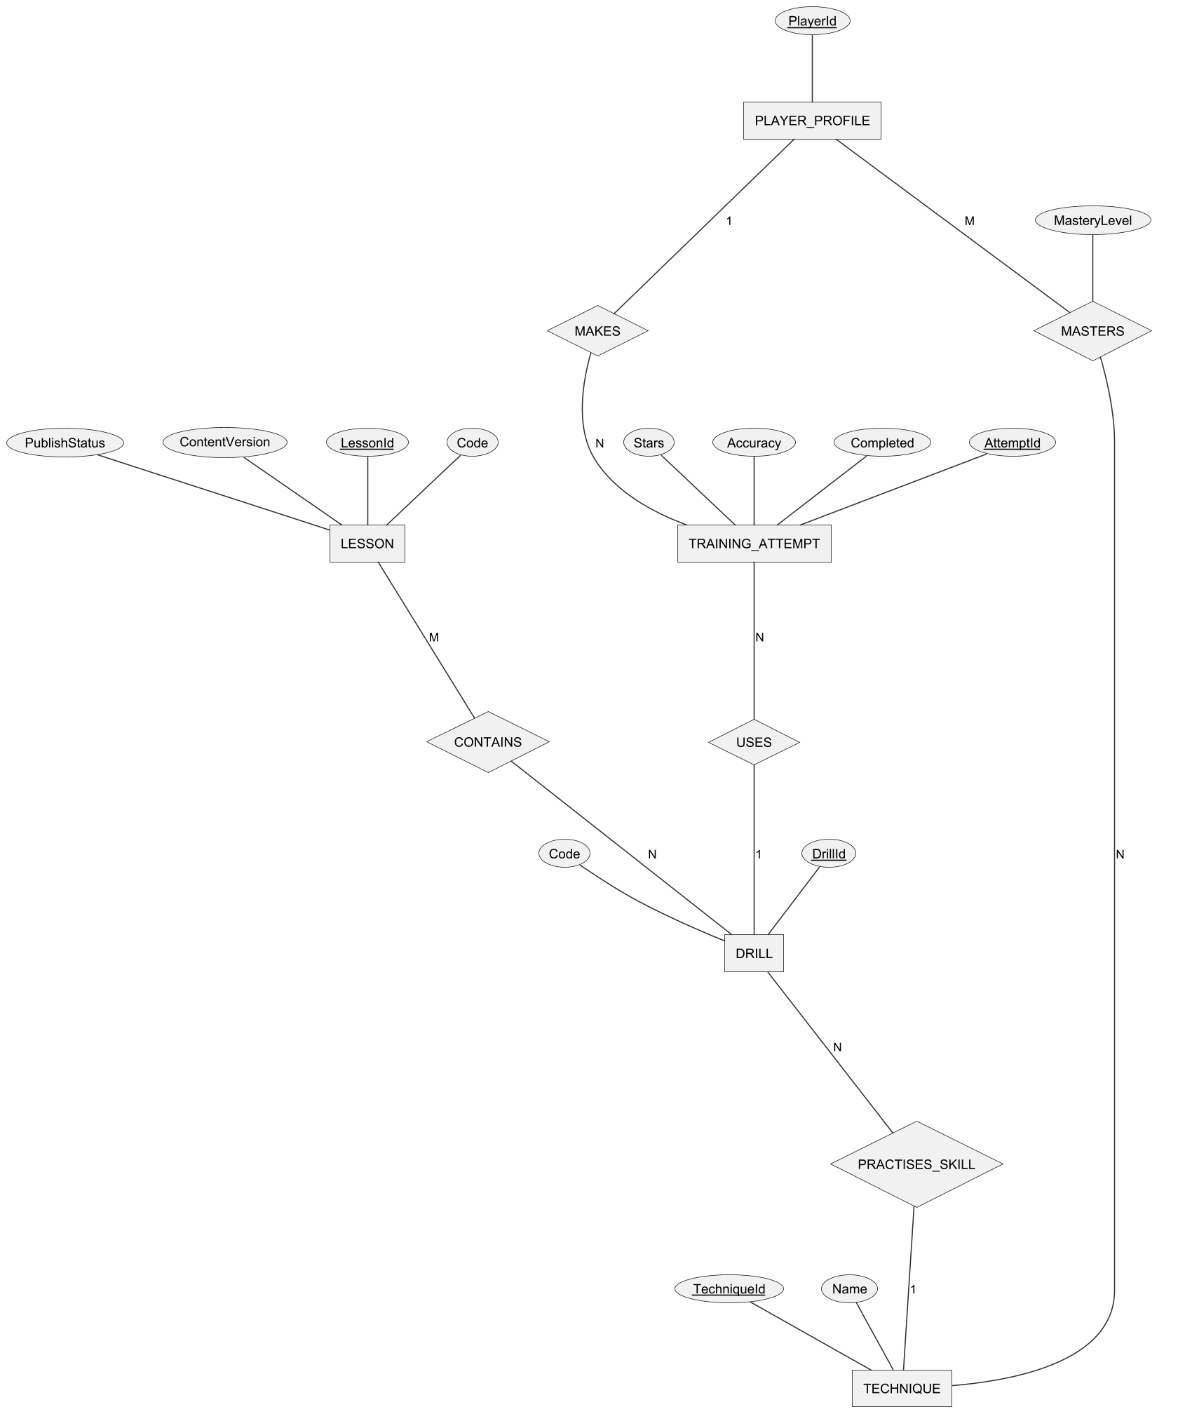
Figure 15. Conceptual ERD – techniques, lessons and training
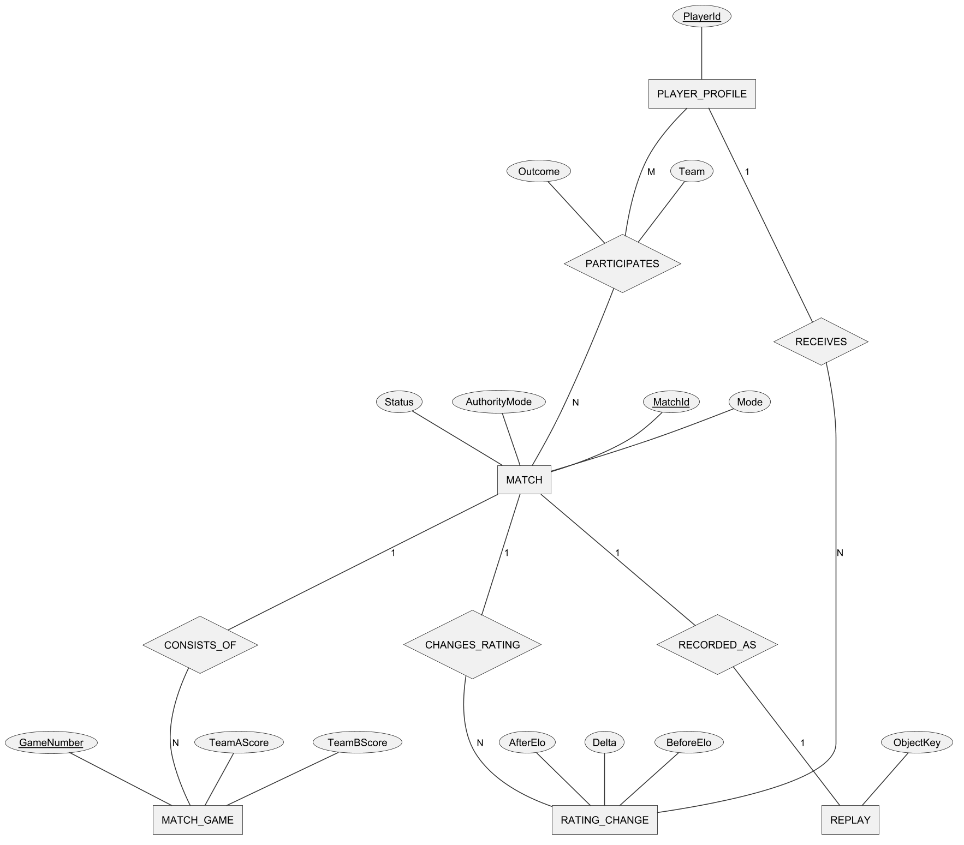
Figure 16. Conceptual ERD – matches, ratings and replays
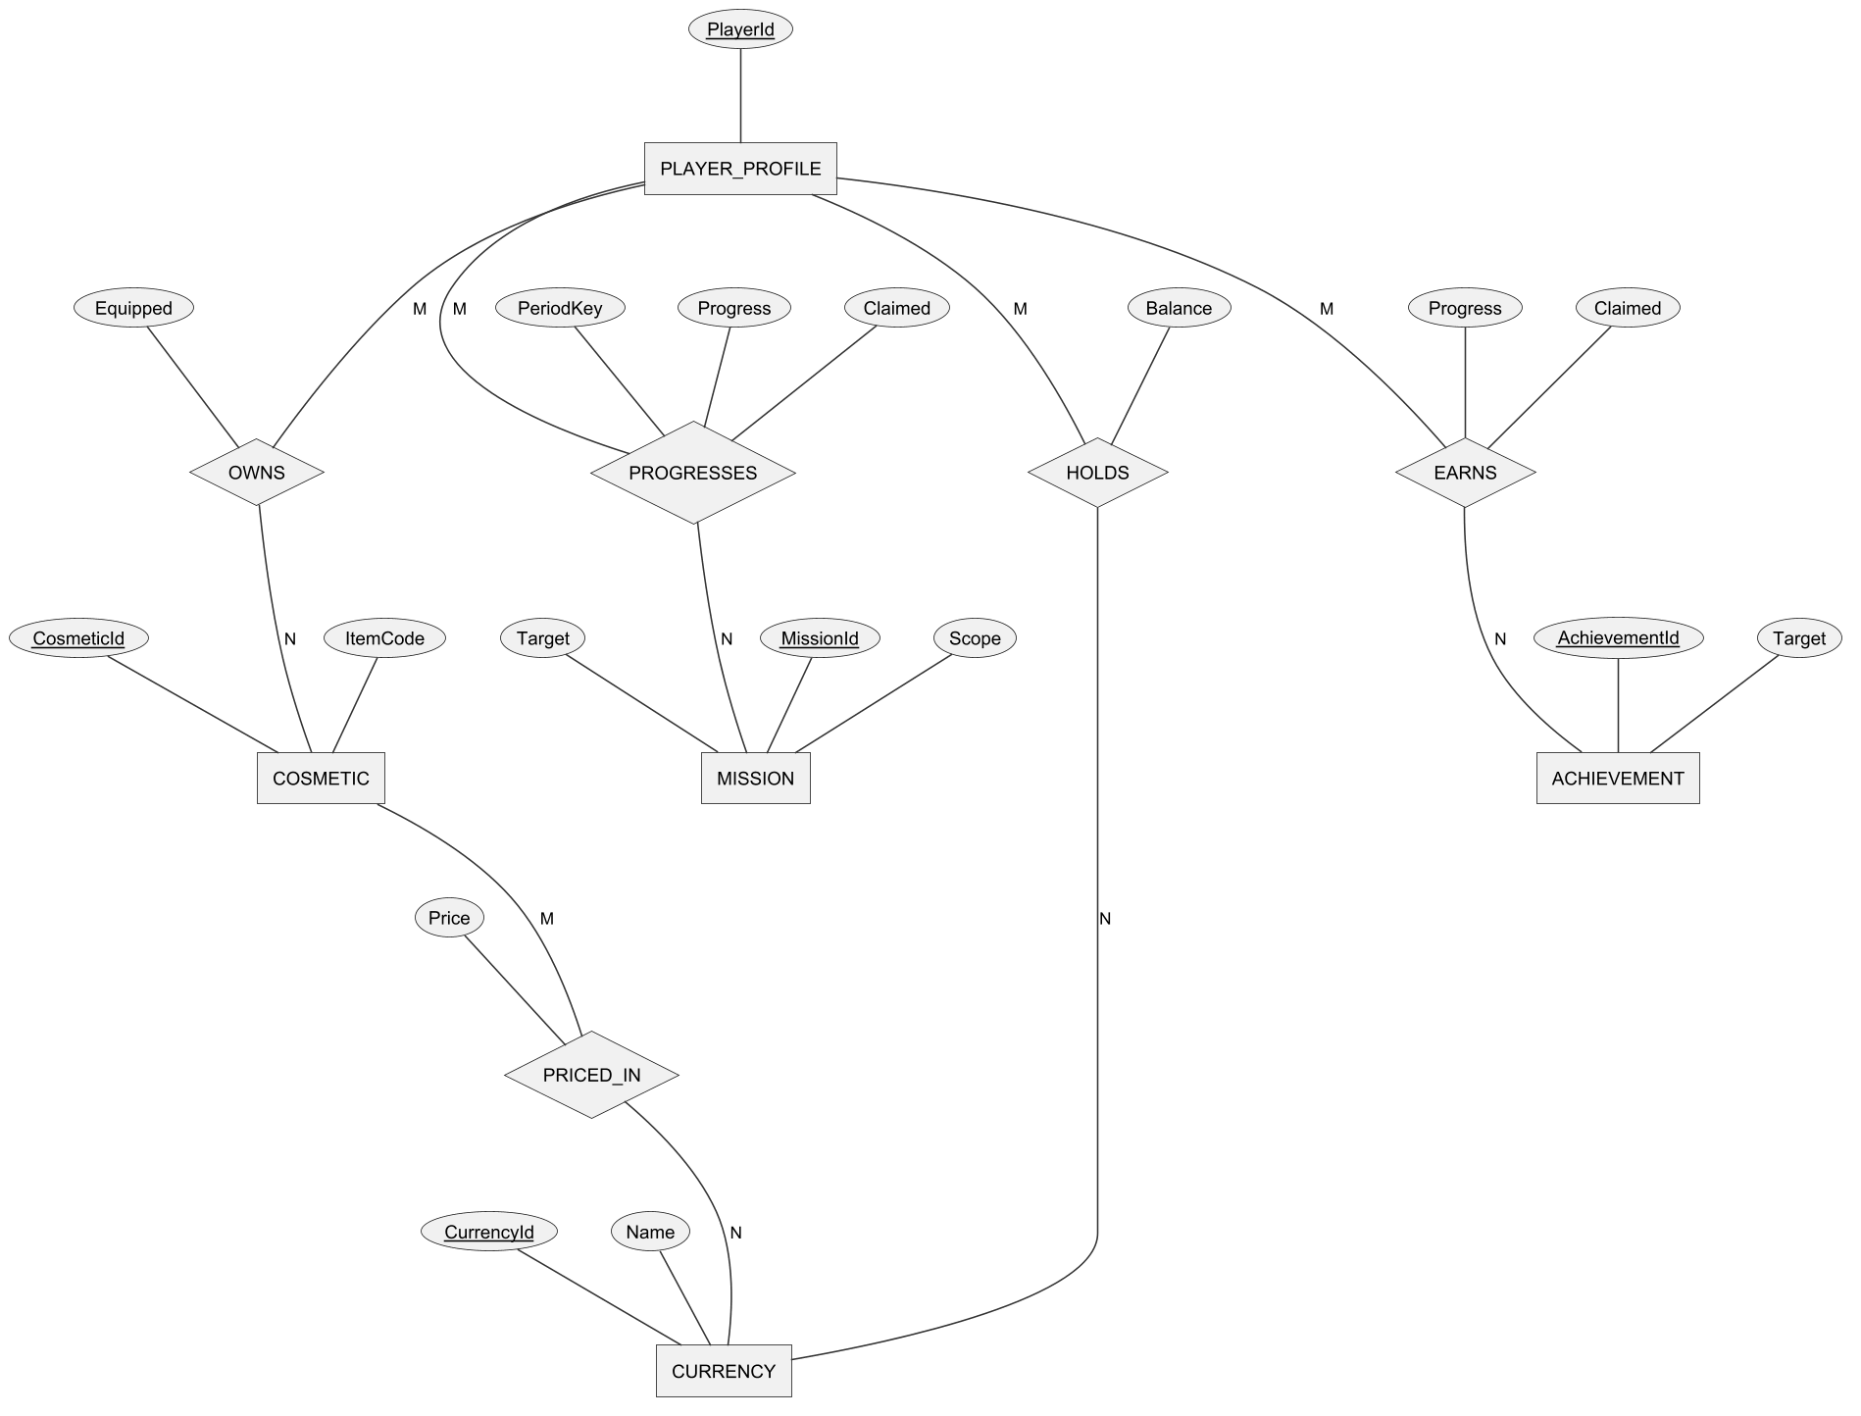
Figure 17. Conceptual ERD – currencies, cosmetics, missions and achievements
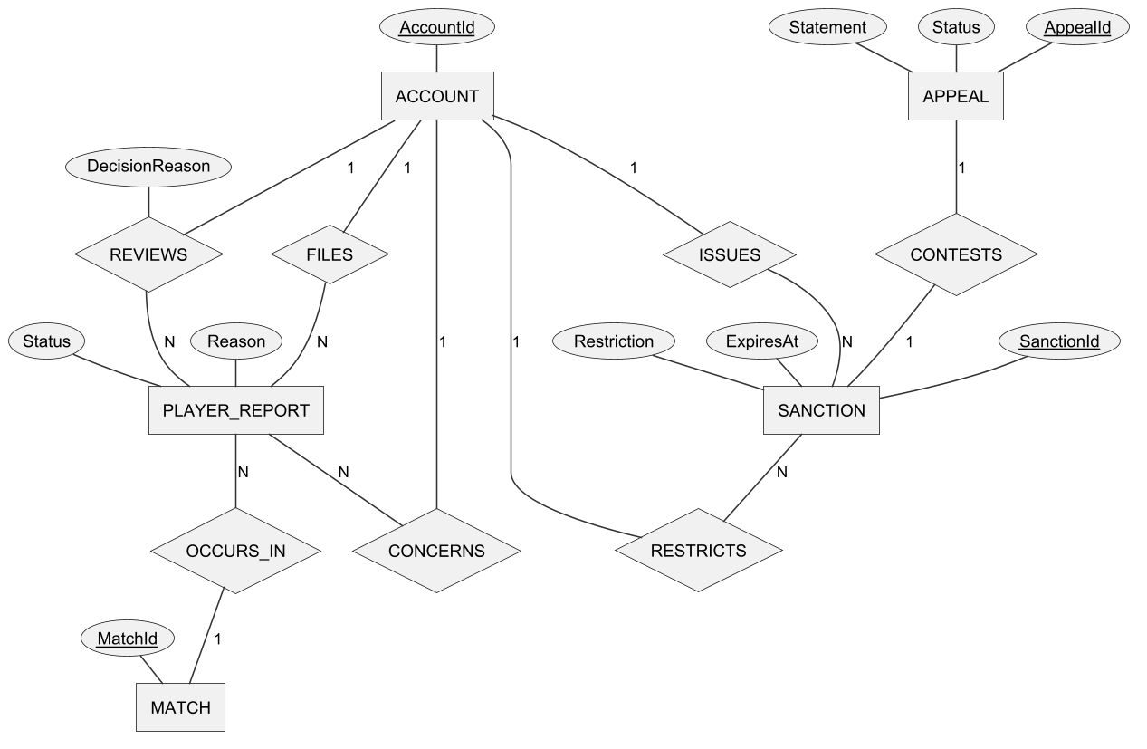
Figure 18. Conceptual ERD – reports, sanctions and appeals
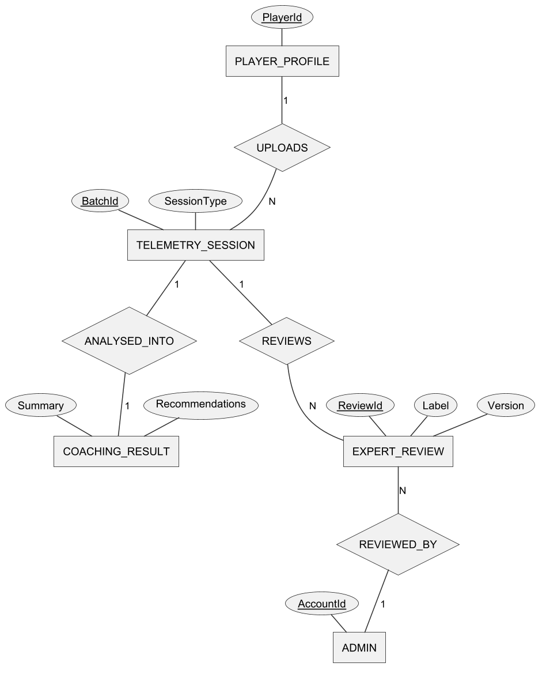
Figure 19. Conceptual ERD – telemetry, coaching and expert review
Entities Description
Table 7. Entities description
# | Entity | Description
1 | ACCOUNT | A registered user identified by e-mail; holds the password hash, status (ACTIVE, SUSPENDED, BANNED) and verification state.
2 | ROLE | Player or Admin; each account has exactly one role.
3 | VERIFICATION_CODE | A one-time code for e-mail verification or password reset, with expiry and remaining attempts.
4 | PLAYER_PROFILE | Game identity of an account: display name, character, level, XP, Elo, onboarding choice and statistics.
5 | TECHNIQUE | A pickleball technique to be learnt (serve, drive, dink, volley, drop, reset, smash, footwork, approach, doubles coverage and transition, modifiers).
6 | LESSON | A unit of the curriculum with code, group, order, target, reward, prerequisite and publication status.
7 | DRILL | An exercise that practises one technique; a lesson contains one or more drills.
8 | TRAINING_ATTEMPT | One run of a drill by a player, with shots, hits, timing, stars and synchronisation receipt.
9 | MATCH | A bot, ranked, matched doubles or custom match with mode, kind, authority mode and status.
10 | MATCH_GAME | One game (1 to 3) of a match with the score of each team; a weak entity identified by match and game number.
11 | RATING_CHANGE | The Elo before, change and after of one player caused by one ranked match.
12 | REPLAY | The stored recording of a match (object key of its manifest).
13 | PLAYER_REPORT | A complaint by one player about another player in a given match, with reason, status and decision.
14 | SANCTION | A suspension (with expiry) or ban applied to an account, with reason, actor and revocation data.
15 | APPEAL | A restricted player's written objection to one sanction, with status and decision.
16 | CURRENCY | In-game currency: Tokenpad (earned by playing) and Elite Token.
17 | COSMETIC | A purchasable or granted item (paddle, outfit, hat) with price and currency.
18 | MISSION | A daily or weekly goal with target and reward.
19 | ACHIEVEMENT | A long-term goal (wins, matches, points, streaks) with a one-time reward.
20 | TELEMETRY_SESSION | The shot-level data captured during a drill or match and uploaded for analysis.
21 | COACHING_RESULT | The AI analysis of a telemetry session: findings, summary, recommendations and optional tier.
22 | EXPERT_REVIEW | An expert's labels for a telemetry session (level, errors, data group) used to evaluate the AI.
23 | ADMIN | An account with the Admin role, shown as a separate box in the coaching diagram for readability.

3.2 Account and Onboarding (FE-01)

FR-01 Register Account and Verify Email
Related use cases: UC-01 Register Account, UC-02 Verify Email
Function trigger: Login screen → link "Đăng ký" (Register). The verification page also opens after a successful registration, or from the link "Bạn cần xác thực email?".
Function description: A visitor creates an account with an e-mail address and a password. The client validates the form, the Web API creates the account in the unverified state, stores a hash of a six-digit one-time password (OTP) and queues an e-mail through Gmail SMTP. The visitor enters the OTP to activate the account; after activation the account can sign in.
Screen layout
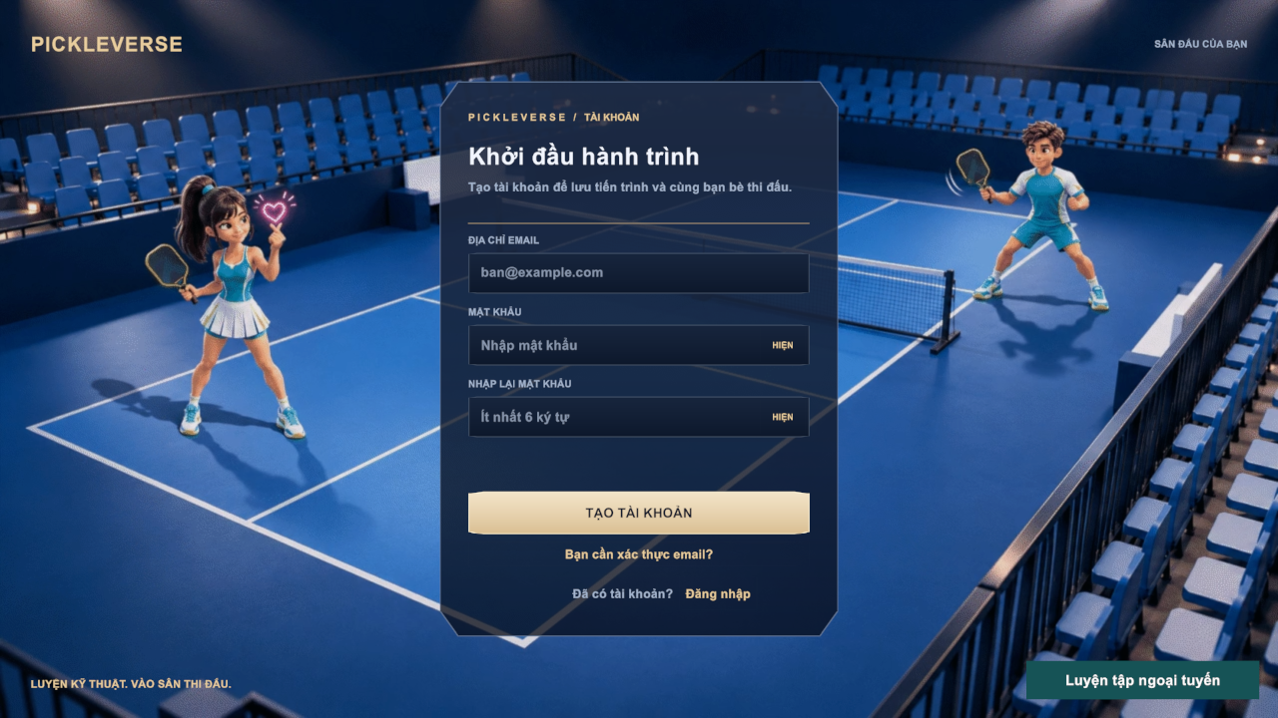
Figure 20. Register screen
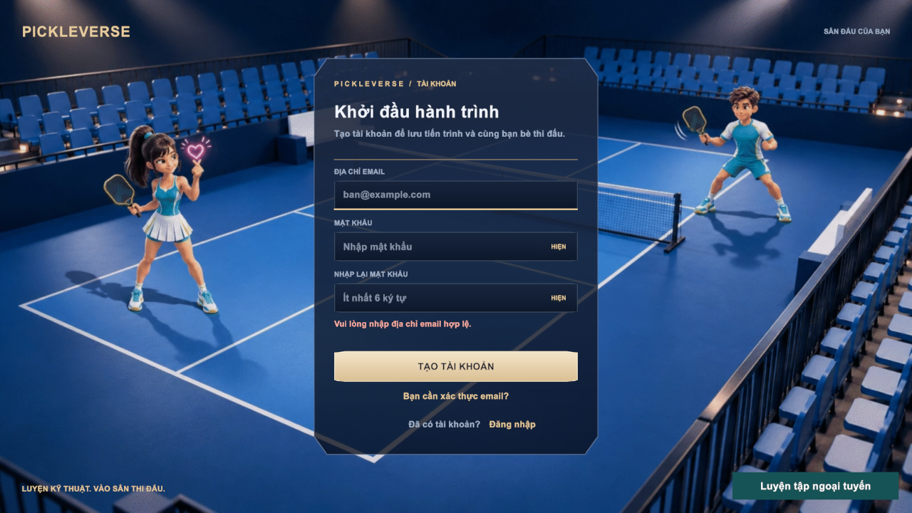
Figure 21. Register screen with an inline validation message
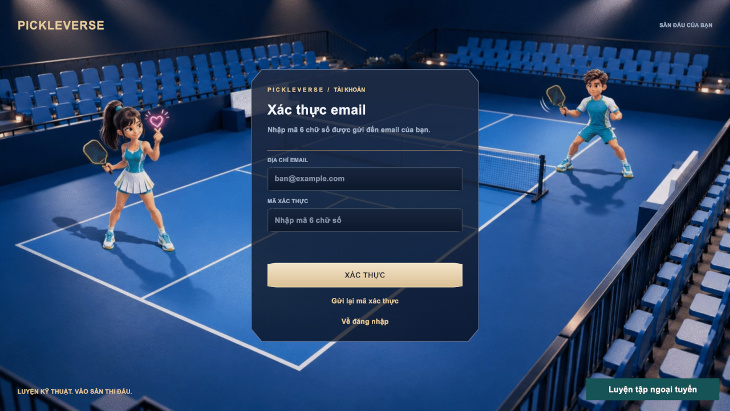
Figure 22. E-mail verification screen
Function details
Table 8. FR-01 data fields
Field | Type | Required | Validation and constraints
Email | Text (≤254) | Yes | Valid e-mail format (MSG01, MSG02); not already registered (MSG06)
Password | Password | Yes | 6–128 characters (MSG03, MSG04, MSG17); show/hide toggle
Confirm password | Password | Yes | Must equal Password (MSG05)
Verification code | Text (6 digits) | Yes | Exactly six digits (MSG08); valid for 10 minutes; at most 5 wrong attempts

Business rules: BR-01, BR-02, BR-03, BR-04.
Normal flow:
1. The visitor enters e-mail, password and confirmation and selects Tạo tài khoản.
2. The client validates the fields; the API creates an ACTIVE but unverified account with the Player role and a player profile.
3. The API sends the OTP e-mail and the client shows MSG07 and the verification page.
4. The visitor enters the six-digit code and selects Xác thực.
5. The API checks the code, marks the e-mail as verified and the client returns to sign-in.
Alternative and exception flows:
• E1 – The e-mail is already registered: MSG06; an unverified owner can use Gửi lại mã xác thực.
• E2 – Resend is requested within 60 seconds of the previous code: HTTP 429 and MSG10.
• E3 – Wrong or expired code: the attempt is counted; after 5 wrong attempts the code is invalid and a new code must be requested.
• E4 – The e-mail cannot be delivered (SMTP not available): MSG22; an administrator can verify the account manually (FR-29).
• E5 – The e-mail is already verified: the client asks the visitor to sign in.

FR-02 Sign In and Sign Out
Related use cases: UC-03 Sign In, UC-05 Sign Out
Function trigger: Login screen → Đăng nhập; Settings → Overview → Đăng xuất. Token refresh runs automatically before the access token expires.
Function description: A visitor signs in with e-mail and password. The API verifies the BCrypt hash, issues a JWT access token (2 hours) and a refresh token (14 days, stored as a SHA-256 hash) and returns the profile summary. The client loads the profile, wallet, catalogue and settings on the Loading screen and opens the Menu. A restricted account receives a token limited to the appeal scope and is taken to Decisions and Appeals. Signing out revokes the refresh token on the server and clears the session on the device.
Screen layout
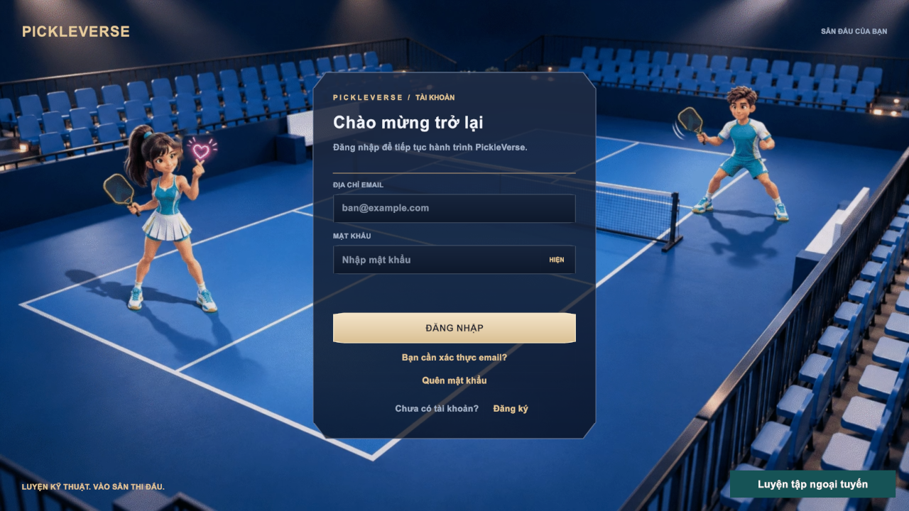
Figure 23. Login screen of the game client
Function details
Table 9. FR-02 data fields
Field | Type | Required | Validation and constraints
Email | Text | Yes | Not empty (MSG01), valid format (MSG02)
Password | Password | Yes | Not empty (MSG03)

Business rules: BR-04, BR-05.
Normal flow:
1. The visitor enters e-mail and password and selects Đăng nhập.
2. The API validates the credentials and returns tokens and the profile; the client shows MSG13 and the Loading screen.
3. On the first sign-in the client asks for the experience level (FR-04); otherwise it opens the Menu.
4. To sign out, the player opens Settings → Overview and selects Đăng xuất; the client returns to the Login screen.
Alternative and exception flows:
• E1 – Wrong e-mail or password: MSG12 (the message does not reveal which field is wrong).
• E2 – The e-mail is not verified: MSG11 and a link to the verification page.
• E3 – The account is suspended or banned: MSG14 and the Decisions and Appeals popup (FR-28).
• E4 – A system bot account tries to sign in: MSG65.
• E5 – The refresh token is expired or revoked: MSG18 and the Login screen.
• A1 – No network and a cached profile exists: the visitor can select Luyện tập ngoại tuyến (FR-09).

FR-03 Reset Password
Related use cases: UC-04 Reset Password
Function trigger: Login screen → Quên mật khẩu.
Function description: A visitor who has forgotten the password requests a reset code. To prevent account enumeration the API always answers with the same neutral message; a code is sent only when the address belongs to a verified account. The visitor enters the code and a new password; the API stores the new hash and revokes every refresh token of the account.
Screen layout
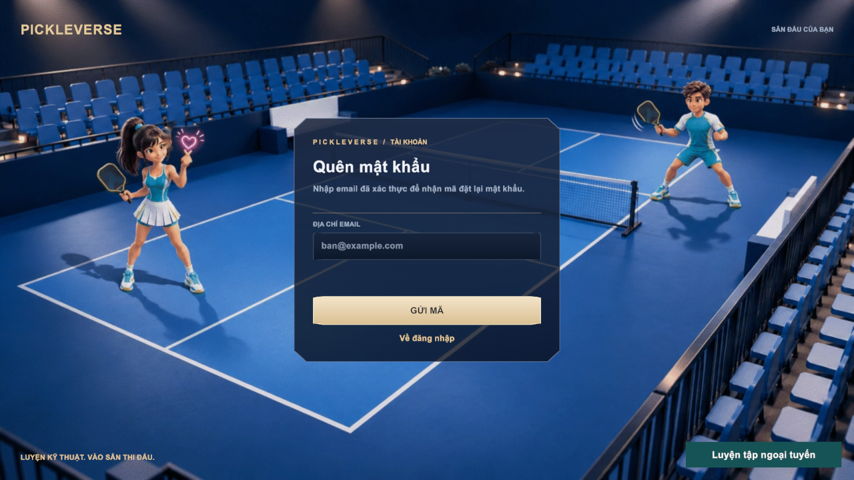
Figure 24. Forgot password screen
Function details
Table 10. FR-03 data fields
Field | Type | Required | Validation and constraints
Email | Text | Yes | Valid format (MSG02)
Reset code | Text (6 digits) | Yes | Valid for 10 minutes; at most 5 attempts (MSG16)
New password / confirmation | Password | Yes | 6–128 characters; equal (MSG04, MSG05, MSG17)

Business rules: BR-02, BR-03, BR-05.
Normal flow:
1. The visitor enters the e-mail address and selects Gửi mã; the client shows MSG15.
2. The visitor enters the code, the new password and its confirmation.
3. The API changes the password, revokes all sessions and the client returns to sign-in.
Alternative and exception flows:
• E1 – Wrong or expired code: MSG16.
• E2 – Resend within 60 seconds: MSG10.

FR-04 Onboarding and Player Profile
Related use cases: UC-06 Choose Experience Level, UC-07 Update Player Name, UC-08 Select Character
Function trigger: First sign-in (experience popup); Menu → name tag or profile card edit icon (name); Menu → Nam / Nữ selector (character).
Function description: At the first sign-in the player answers MSG21. Người mới (Beginner) opens the tutorial; Đã thành thạo (Experienced) goes to the Menu. The answer is saved once. The player can later change the display name and choose the male or female character; the character is used in the menu, training and matches.
Screen layout
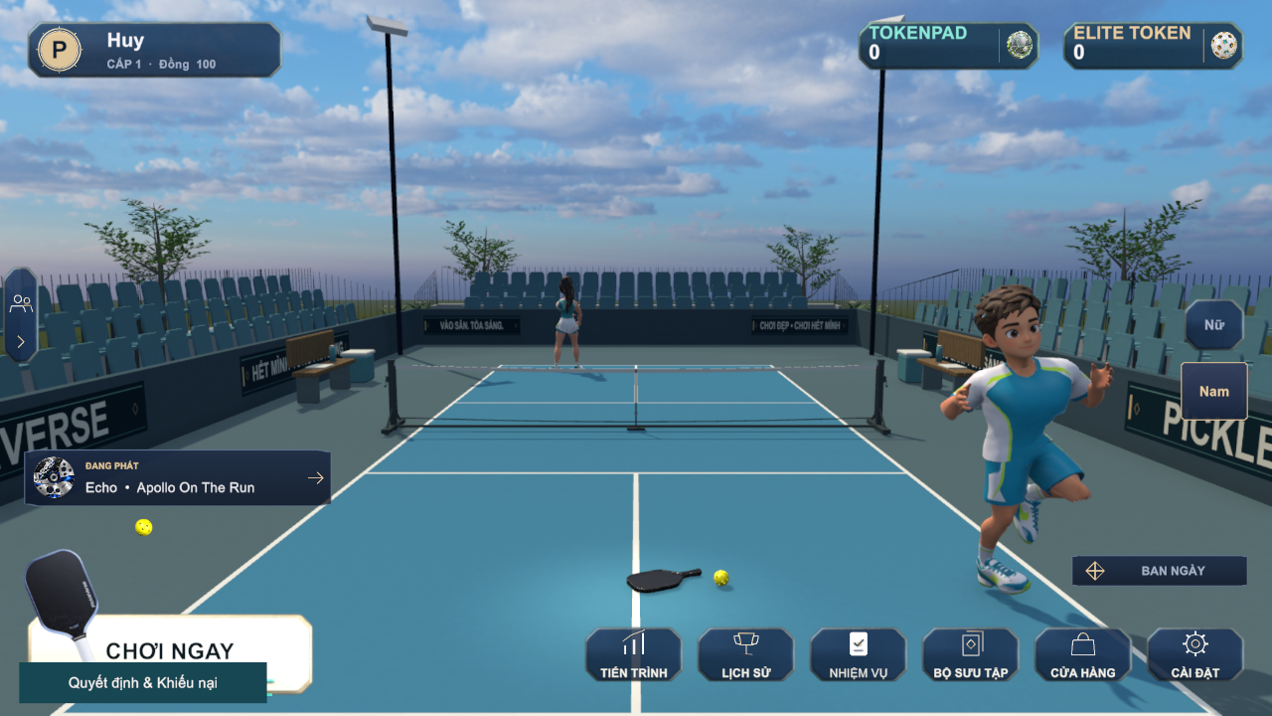
Figure 25. Menu (lobby) of a signed-in player
Function details
Table 11. FR-04 data fields
Field | Type | Required | Validation and constraints
Experience level | Choice | Yes (once) | Beginner or Experienced; cannot be changed afterwards
Display name | Text | Yes | 3–18 characters, no control characters, unique (MSG19, MSG20)
Character | Choice | Yes | Male or Female; default Male

Business rules: BR-06, BR-07, BR-08.
Normal flow:
1. The player answers the experience question; the choice is saved.
2. The player edits the name and confirms; the API checks length and uniqueness and saves it.
3. The player selects Nam or Nữ; the menu character changes immediately and the choice is saved.
Alternative and exception flows:
• E1 – Name outside 3–18 characters: MSG19.
• E2 – Name already used: MSG20.
• E3 – The player is in a room, searching or in a match: profile changes are disabled until the activity ends.

FR-05 Configure Game Settings
Related use cases: UC-09 Configure Game Settings
Function trigger: Menu → Cài đặt, or Esc during a match or drill.
Function description: The player adjusts audio (music and effects volume), graphics (the quality options of the Graphics tab) and controls (keyboard bindings for PC and the touch layout for phones). Changes are previewed and stored on the device when the player selects Áp dụng và lưu.
Screen layout
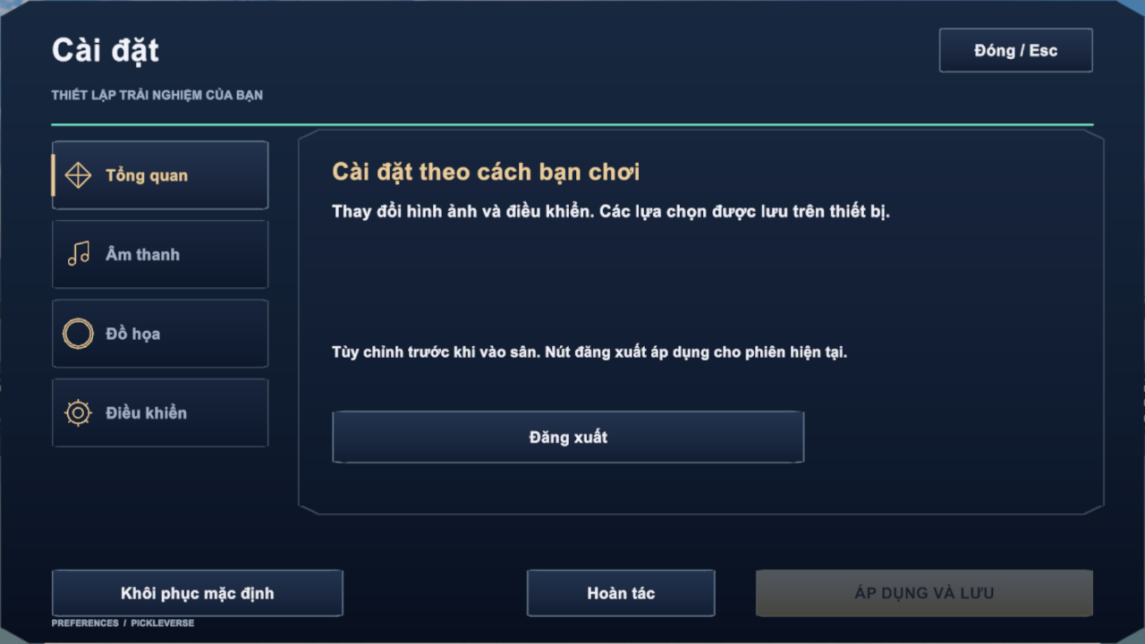
Figure 26. Settings – Overview tab
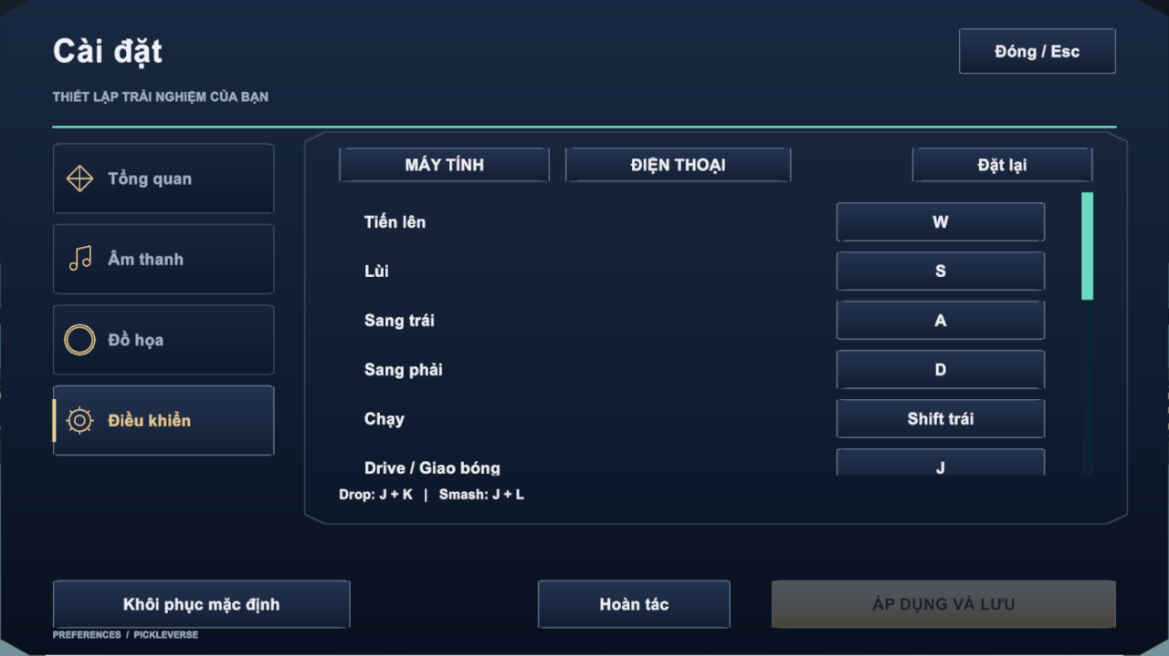
Figure 27. Settings – Controls tab with key bindings
Function details
Table 12. FR-05 data fields
Field | Type | Required | Validation and constraints
Music / effects volume | Slider 0–100 | No | Default from the build
Graphics options | Choice | No | Applied after Apply and save
Key binding | Key | No | One key per action; Restore defaults resets all (defaults: W/A/S/D move, Left Shift run, J drive and serve, K dink, L volley, U power, I cross)

Business rules: BR-17.
Normal flow:
1. The player changes values; Áp dụng và lưu becomes active.
2. The player saves; settings apply immediately and persist on the device.
Alternative and exception flows:
• A1 – Hoàn tác restores the last saved values; Khôi phục mặc định restores factory values.

3.3 Tutorial and Technique Training (FE-02)

FR-06 Complete Tutorial
Related use cases: UC-10 Complete Tutorial
Function trigger: Automatically after choosing Beginner (FR-04); Mode Selection → Tutorial / Hướng dẫn cơ bản.
Function description: The tutorial teaches the court, the rules and the controls in 17 short steps (about 2–3 minutes). Each step shows a title, an explanation and a demonstration on the court, for example the court dimensions, a ball that does not cross the net, the two-bounce rule and the non-volley zone. Completion is saved to the profile.
Screen layout
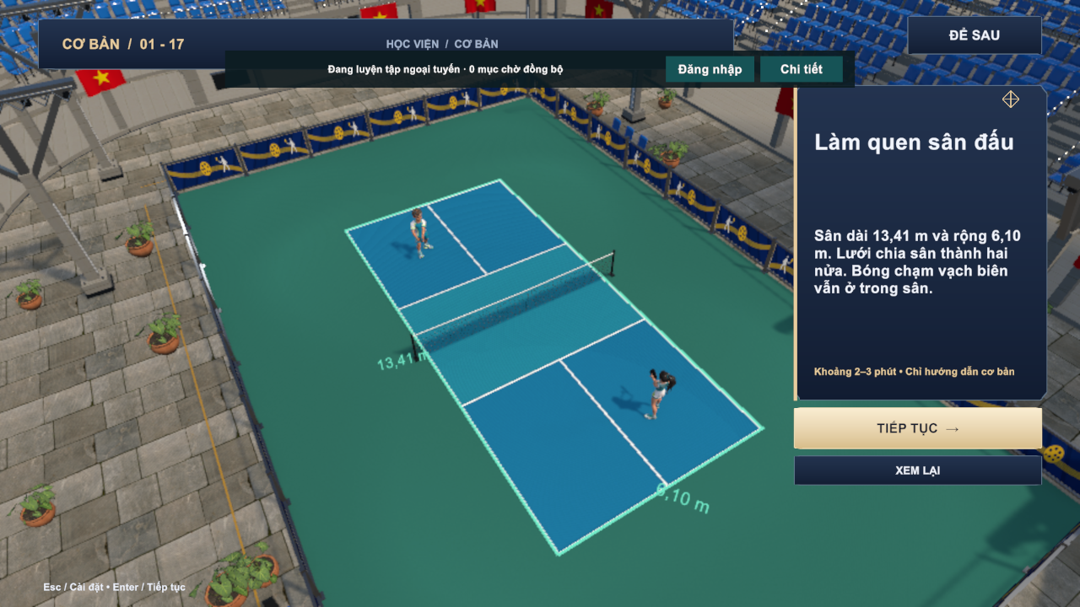
Figure 28. Tutorial step 1 – getting to know the court
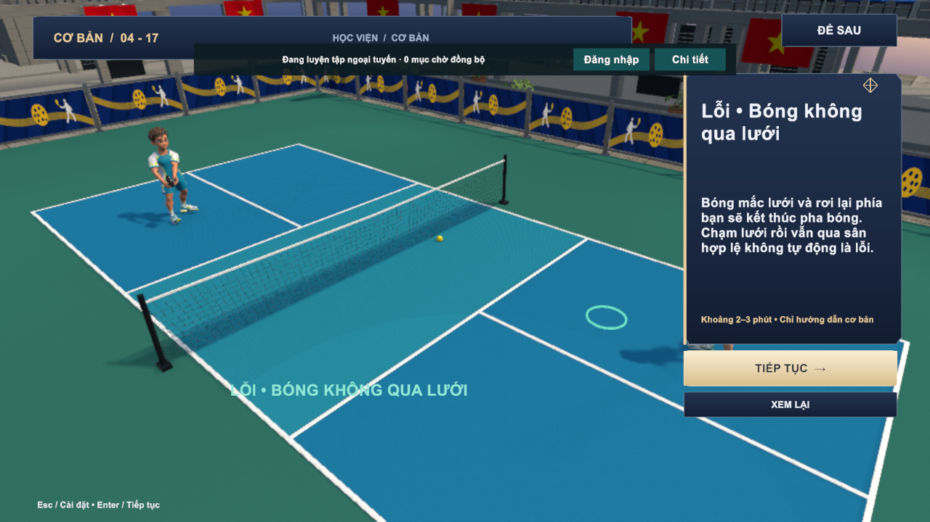
Figure 29. Tutorial step 4 – fault: the ball does not cross the net
Function details
Business rules: BR-09 to BR-14.
Normal flow:
1. The tutorial opens at step 1.
2. The player reads each step and selects Tiếp tục (Enter) to continue or Xem lại to replay the demonstration.
3. After step 17 the completion is saved and the Menu opens.
Alternative and exception flows:
• A1 – Để sau leaves the tutorial; it can be reopened from Mode Selection.

FR-07 Browse Lessons
Related use cases: UC-11 Browse Lessons
Function trigger: Mode Selection → Luyện tập; Training Progress → Tiếp tục luyện.
Function description: The academy lists the 15 published lessons grouped as Basic, Control, Advanced and Doubles. Each row shows the group, the first-pass reward, the best stars and whether the lesson is unlocked. Selecting a lesson opens its briefing: coach explanation, target, reward and the star rules.
Screen layout
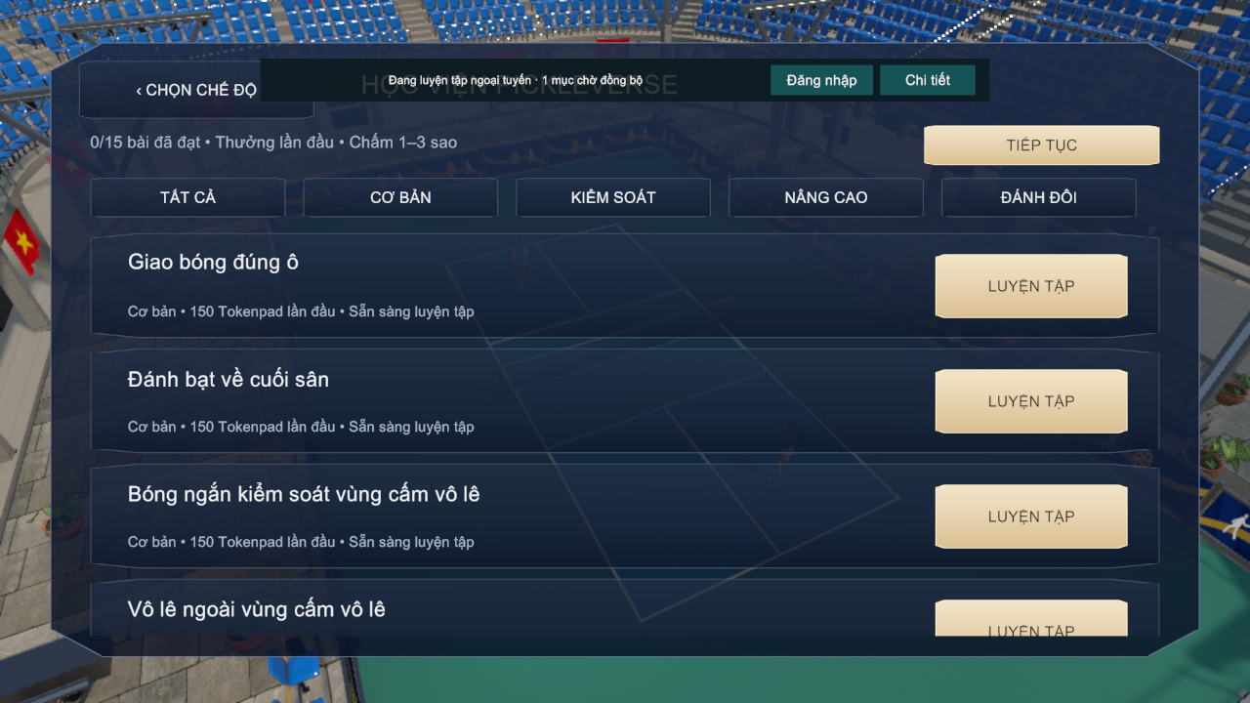
Figure 30. Lesson catalogue with group tabs
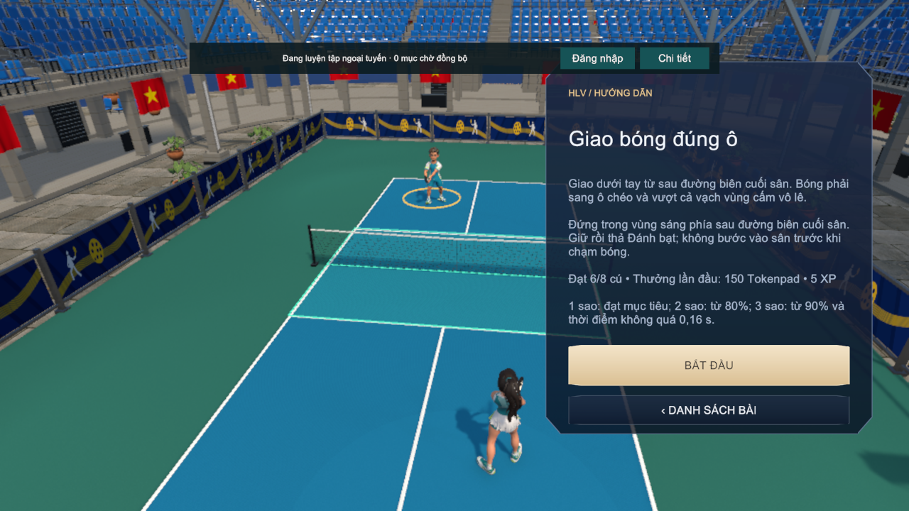
Figure 31. Lesson briefing for "Giao bóng đúng ô" (serve)
Function details
Business rules: BR-18, BR-19, BR-20.
Normal flow:
1. The player opens the academy; the catalogue loads from the server (or the cached catalogue when offline).
2. The player filters by group and selects Luyện tập on a lesson.
3. The briefing opens; Bắt đầu starts the drill (FR-08).
Alternative and exception flows:
• E1 – The lesson is locked: the start button is disabled and MSG23 is shown.

FR-08 Practise Drill
Related use cases: UC-12 Practise Drill
Function trigger: Lesson briefing → Bắt đầu; Drill Result → Luyện lại.
Function description: The player performs the drill on the training court, for example eight serves into the highlighted service court. For each shot the game measures whether the ball lands in the target area and the timing error between the key release and the ideal contact. In-drill feedback tells the player whether the release was early or late. At the end the client sends the attempt and its telemetry to the API, which validates it, applies the stars and the first-pass reward and returns a receipt.
Screen layout
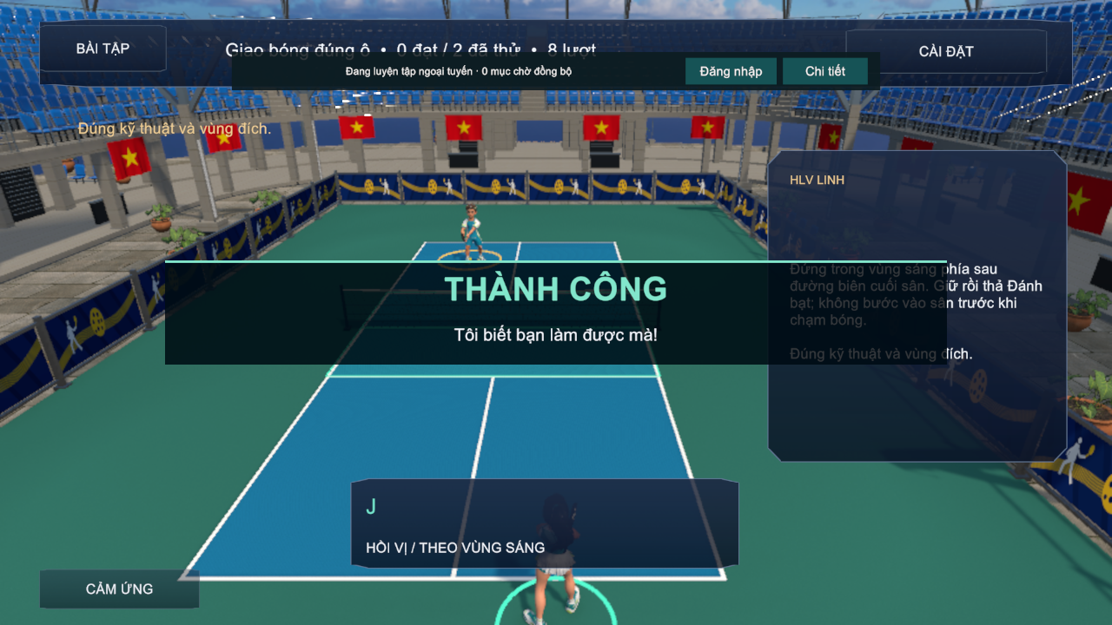
Figure 32. Practice HUD with coach panel and success feedback
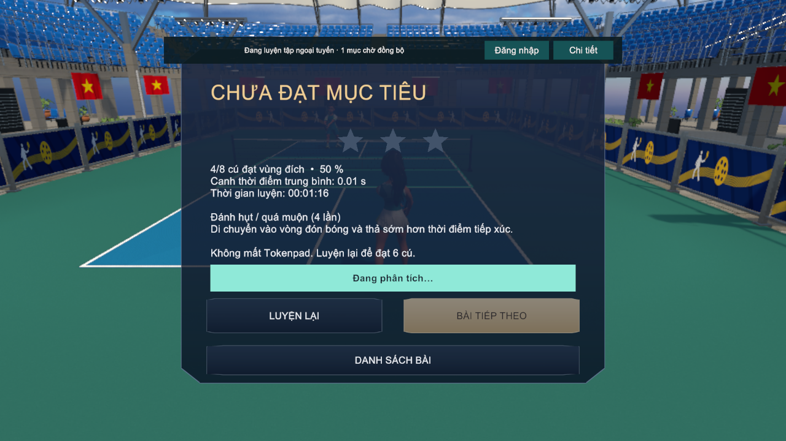
Figure 33. Drill result – target not reached
Function details
Table 13. FR-08 data fields
Field | Type | Required | Validation and constraints
Shots / target | Integer | System | Fixed per lesson (for example 6 of 8 for the serve lesson)
Hits in target | Integer | System | Counted by the rules engine
Mean timing error | Seconds | System | Absolute difference between release and ideal contact
Stars | 0–3 | System | Computed by BR-18; the best result is kept

Business rules: BR-16, BR-17, BR-18, BR-20.
Normal flow:
1. The drill starts and the HUD shows lesson, shot counter and key hints.
2. The player hits the required shots; feedback (MSG26, MSG27) appears after each shot.
3. After the last shot the Drill Result popup shows stars, accuracy, mean timing, time, the most frequent error and a tip.
4. The API stores the attempt; on the first pass it grants the lesson reward and unlocks the next lesson.
5. The coaching analysis appears when ready (FR-19).
Alternative and exception flows:
• A1 – Target not reached: MSG24 and MSG25; no currency is lost and Bài tiếp theo stays disabled.
• A2 – The device is offline: the attempt is queued for synchronisation (FR-09).
• E1 – The attempt is rejected by the server (for example inconsistent telemetry): receipt REJECTED and no reward.

FR-09 Offline Training and Synchronisation
Related use cases: UC-13 Practise Drill Offline, UC-14 Synchronise Offline Results
Function trigger: Login → Luyện tập ngoại tuyến when a profile is cached; automatic synchronisation when the connection returns, or banner → Đăng nhập.
Function description: A player who has signed in on the device at least once can train without a connection. The client uses the cached catalogue and profile, stores every finished attempt with a unique request ID in a local queue and shows the offline banner MSG28. When the player is online again, the queue is sent; the API applies each request at most once and answers APPLIED, DUPLICATE or REJECTED. Online-only features (bot and online matches, shop) are disabled offline.
Screen layout
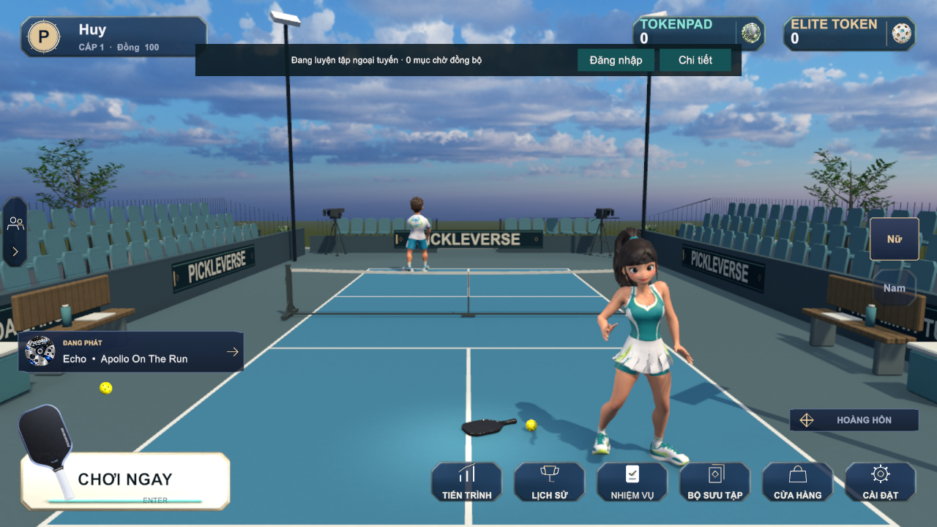
Figure 34. Menu in offline training mode with the offline banner
Function details
Business rules: BR-21.
Normal flow:
1. The player starts offline training from the Login screen.
2. Drills work as in FR-08; each result is added to the queue and the banner shows the pending count.
3. When connected, the client sends the queue; applied items are removed and rewards are added to the profile.
Alternative and exception flows:
• A1 – The same request is sent twice: receipt DUPLICATE; no second reward.
• E1 – No cached profile on the device: the offline button is not shown.
• E2 – A queued item is invalid: receipt REJECTED; the item is removed and the player is informed through Chi tiết.

FR-10 View Training Progress
Related use cases: UC-15 View Training Progress
Function trigger: Menu → Tiến trình.
Function description: The progress popup summarises the player's learning: passed lessons out of 15, the next lesson, the latest post-session feedback, total practice time, the most frequent error and the most retried lesson, and the best result of every lesson with a Retry shortcut. Tabs give access to daily and weekly missions (FR-21).
Screen layout
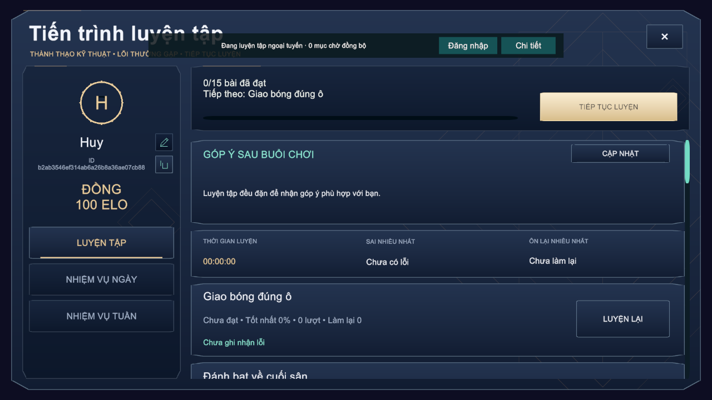
Figure 35. Training progress popup
Function details
Business rules: BR-18.
Normal flow:
1. The player opens Progress; the data is loaded from the profile.
2. The player selects Luyện lại on a lesson to open its briefing.

3.4 Core Gameplay and Bot Practice (FE-03)

FR-11 Control the Player and Hit Shots
Related use cases: UC-12, UC-16, UC-25
Function trigger: Any rally in a drill, bot match or online match.
Function description: The player moves with W/A/S/D (or the virtual joystick on phones), runs with Left Shift and hits by holding and releasing shot keys. One of seven shot kinds is chosen from the key combination when the first key is released; U adds power and I aims cross-court. The paddle contact is accepted only inside the timing window, and the quality of the contact (Perfect, Good, early or late) affects the ball speed and accuracy. The ball flight, bounce and net contact are simulated at 120 Hz.
Screen layout
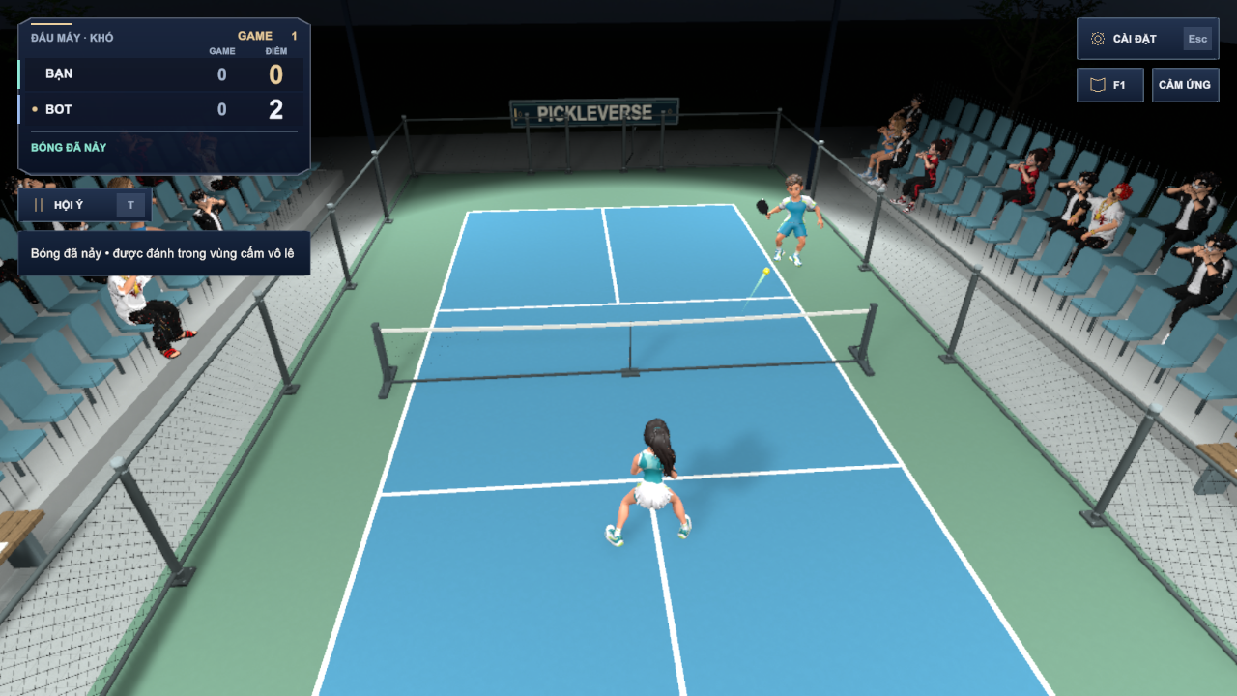
Figure 36. Rally in a bot match with score panel and rule feedback
Table 14. FR-11 screen layout
Area | Elements and behaviour
Score panel (top left) | Mode and difficulty, game number, games and points of each side, serving side, rule hint
Controls (top right) | Settings (Esc), help (F1), touch layout toggle
Court | Player character, opponent, ball, landing marker and fault banner

Function details
Business rules: BR-16, BR-17.
Normal flow:
1. The player moves to the ball and holds a shot key (J, K or L, alone or combined).
2. The player releases the key close to the contact moment; the game selects the shot kind and checks the timing.
3. The ball is hit towards the target computed from the shot kind and modifiers.
Alternative and exception flows:
• A1 – Release outside ±65 ms of the ideal contact: no contact (miss) and feedback MSG26 or MSG27.
• A2 – Invalid key combination: the input is ignored until all keys are released.

FR-12 Apply Singles Match Rules
Related use cases: UC-16, UC-25
Function trigger: Every rally of a bot or online match.
Function description: The rules engine decides legal serves, faults, points, games and the match winner according to the official singles rules simplified for the game. In online matches the same engine runs on the dedicated server, which is the only authority for the score.
Screen layout
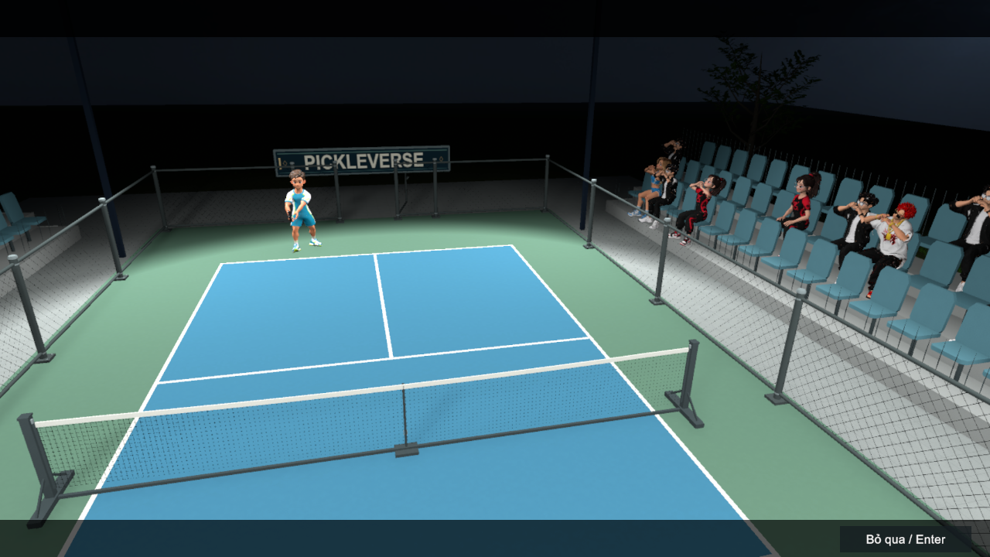
Figure 37. Bot match introduction
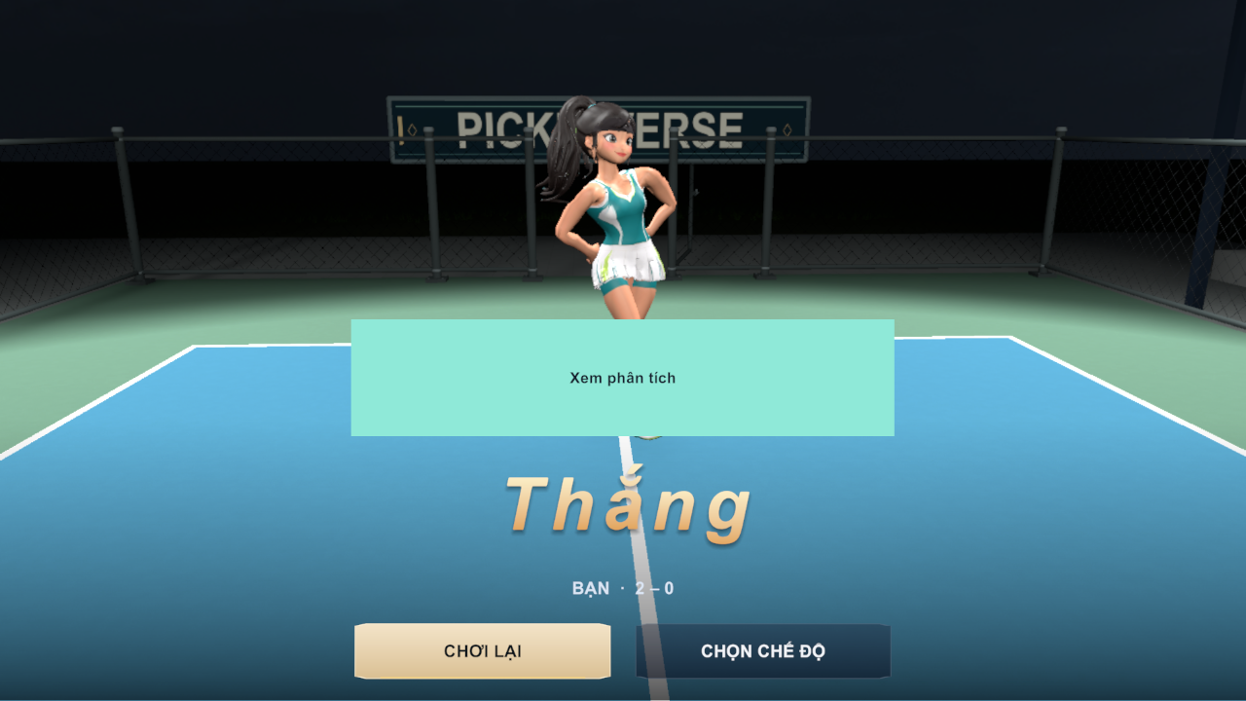
Figure 38. Match result – victory 2–0
Function details
Business rules: BR-09 to BR-15.
Normal flow:
1. The server of the rally serves underhand from behind the baseline into the diagonal service court within 10 seconds.
2. The return and the third shot must bounce; afterwards volleys are allowed outside the non-volley zone.
3. When a fault occurs, the rally ends, a fault banner (MSG30) is shown and the point or side-out is applied.
4. A game ends at 11 points with a 2-point lead; the first side to win two games wins the match (MSG31).
Alternative and exception flows:
• A1 – A side calls a time-out (at most two per game): the match pauses.
• A2 – In the third game the players change ends when a side reaches 6 points.
• E1 – The serve timer expires: fault ServeTimeout and MSG29.

FR-13 Set Up and Play a Bot Match
Related use cases: UC-16 Play Bot Match
Function trigger: Menu → Chơi ngay → Mode Selection → Đấu với bot → Bot Match Setup → Vào sân.
Function description: The player chooses the difficulty, the time of day and the court, then plays a singles match against the computer. Easy, Medium and Hard use fixed reaction and accuracy settings; the adaptive option uses a behaviour-tree bot whose tier follows the player's Elo. After the match the result popup shows the winner, scores and rewards, and the coaching analysis can be opened.
Screen layout
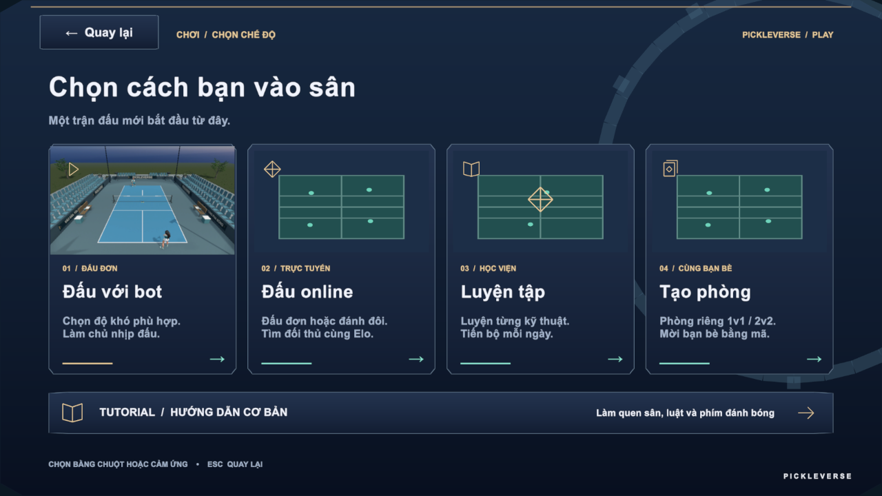
Figure 39. Mode selection
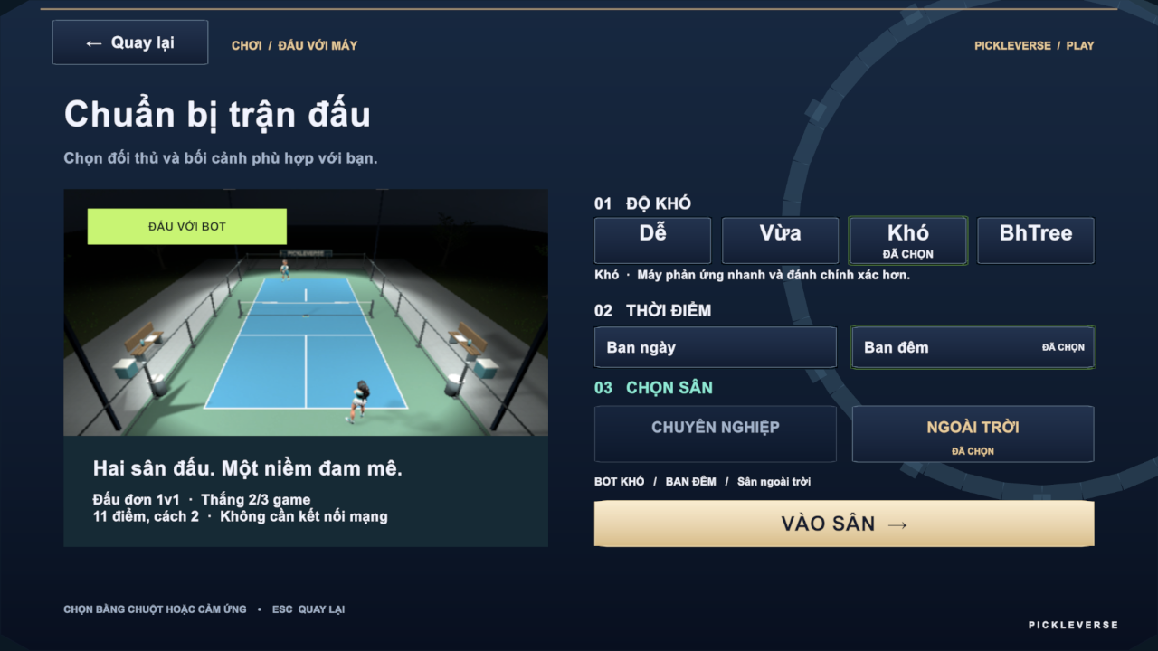
Figure 40. Bot match setup
The layout is also shown in Figure 38.
Function details
Table 15. FR-13 data fields
Field | Type | Required | Validation and constraints
Difficulty | Choice | Yes | Easy, Medium, Hard or Adaptive
Time of day | Choice | Yes | Day or night
Court | Choice | Yes | Professional or outdoor

Business rules: BR-10 to BR-16, BR-22, BR-31, BR-32.
Normal flow:
1. The player selects the options and Vào sân; the intro cinematic plays.
2. The match is played with FR-11 and FR-12.
3. At the end the API settles the result: rewards and XP are added; Elo does not change in a practice bot match.
4. The player selects Chơi lại, Chọn chế độ or Xem phân tích.
Alternative and exception flows:
• A1 – Ranked Bot match assigned by matchmaking (FR-14): Elo changes according to BR-23.
• E1 – The device is offline: the bot match card is disabled.

3.5 Online Matches (FE-04)

FR-14 Find a Ranked Match
Related use cases: UC-19 Find Ranked Match, UC-20 Confirm Match Readiness
Function trigger: Mode Selection → Đấu online → Online Lobby → Đấu đơn 1v1 → Tìm trận.
Function description: The player joins the ranked singles queue. The matchmaking worker pairs two searching players whose Elo is within the pairing window; both must accept within 10 seconds. If no human opponent is found within 180 seconds, a ranked bot opponent is assigned. When all players accept, the API allocates the dedicated server and issues signed tickets, and the clients load the multiplayer court.
Screen layout
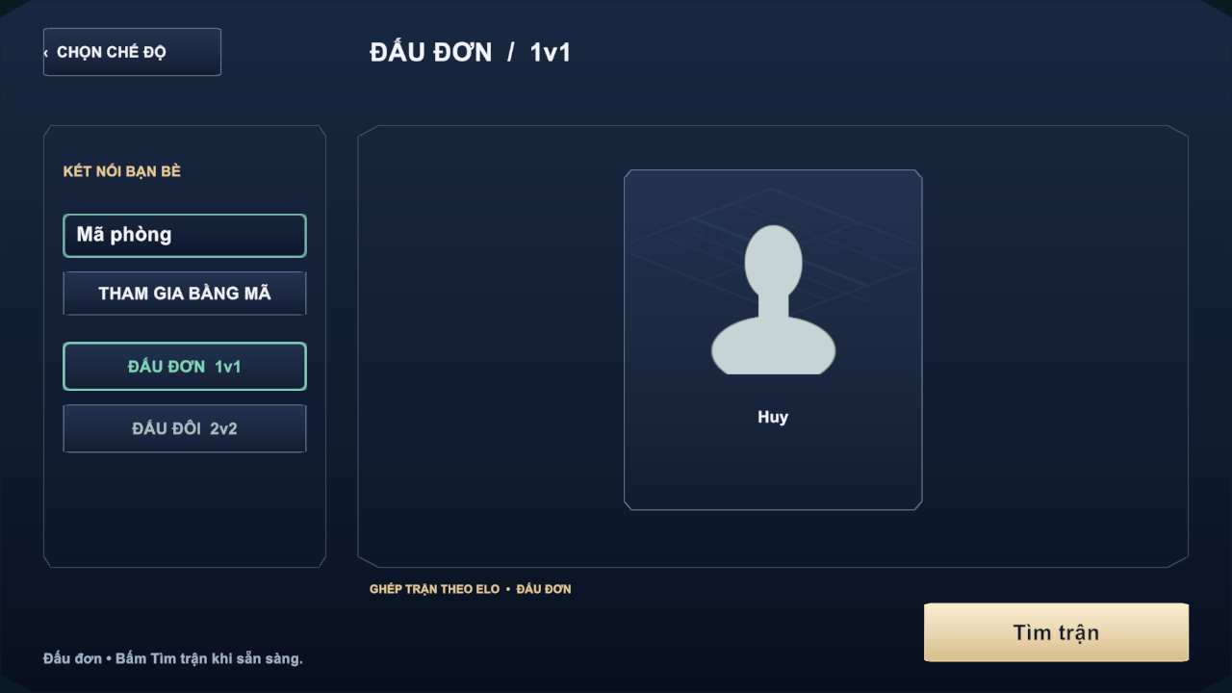
Figure 41. Online lobby – singles
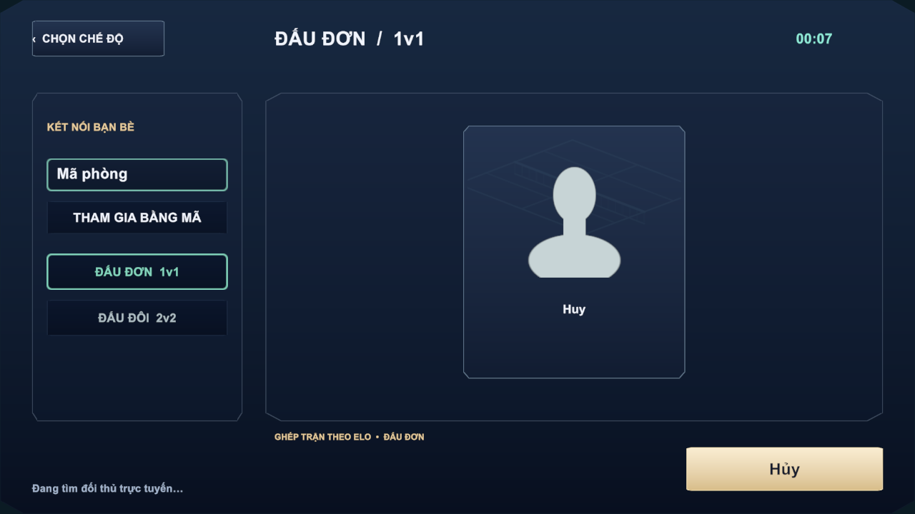
Figure 42. Searching for an opponent with elapsed time
Function details
Business rules: BR-22 to BR-27.
Normal flow:
1. The player selects Tìm trận; MSG32 and a timer are shown.
2. A pair is found; the Ready Check shows MSG33 with a 10-second countdown.
3. Both players accept; the server allocates the match and the court loads (FR-16).
Alternative and exception flows:
• A1 – No opponent within 180 seconds: a ranked bot is assigned and the match starts on the dedicated server.
• A2 – The player selects Hủy while searching: the ticket is cancelled.
• E1 – A player declines or the countdown ends: the offer closes; the decliner sees MSG35 and the other player returns to the queue.
• E2 – The dedicated server is busy: MSG36 and the request waits for the slot.
• E3 – The player already has a search or an unfinished match: MSG41.
• E4 – Search expired: MSG34.

FR-15 Private Rooms and Invitations
Related use cases: UC-21 Create Private Room, UC-22 Join Room by Code, UC-23 Invite Friend to Room, UC-24 Respond to Room Invitation
Function trigger: Mode Selection → Tạo phòng; Online Lobby → Mã phòng + Tham gia bằng mã; friend list → invite.
Function description: A player creates a singles (2 players) or doubles (up to 4 players) room. Other players join with the room code or accept an invitation sent to an online friend. The host can change teams, remove a guest and start the match. Custom matches are unrated and give no Elo.
Screen layout
The layout is also shown in Figure 41.
Function details
Table 16. FR-15 data fields
Field | Type | Required | Validation and constraints
Room code | Text | Yes (to join) | Code of an open room on Photon; wrong code → MSG39
Mode | Choice | Yes | Singles 1v1 or Doubles 2v2

Business rules: BR-22, BR-30, BR-38.
Normal flow:
1. The host creates the room; the lobby shows the room code and roster slots.
2. Guests join by code or by accepting an invitation.
3. The host starts the match; the dedicated server is allocated as in FR-14.
Alternative and exception flows:
• E1 – Room full: MSG37.
• E2 – Room closed or the player was removed: MSG38.
• E3 – Invited player is busy or offline: MSG40.
• E4 – Blocked players cannot invite each other (BR-38).

FR-16 Play an Online Match
Related use cases: UC-25 Play Online Match
Function trigger: Automatically after the ready check (FR-14) or when the host starts a room (FR-15).
Function description: Each client connects to the dedicated server with its signed ticket through Photon Fusion. The server simulates the ball and applies the rules (FR-12); clients send only input and render server state with interpolation. The server sends heartbeats to the API every 8 seconds, records telemetry and the replay, and reports the final result.
Screen layout
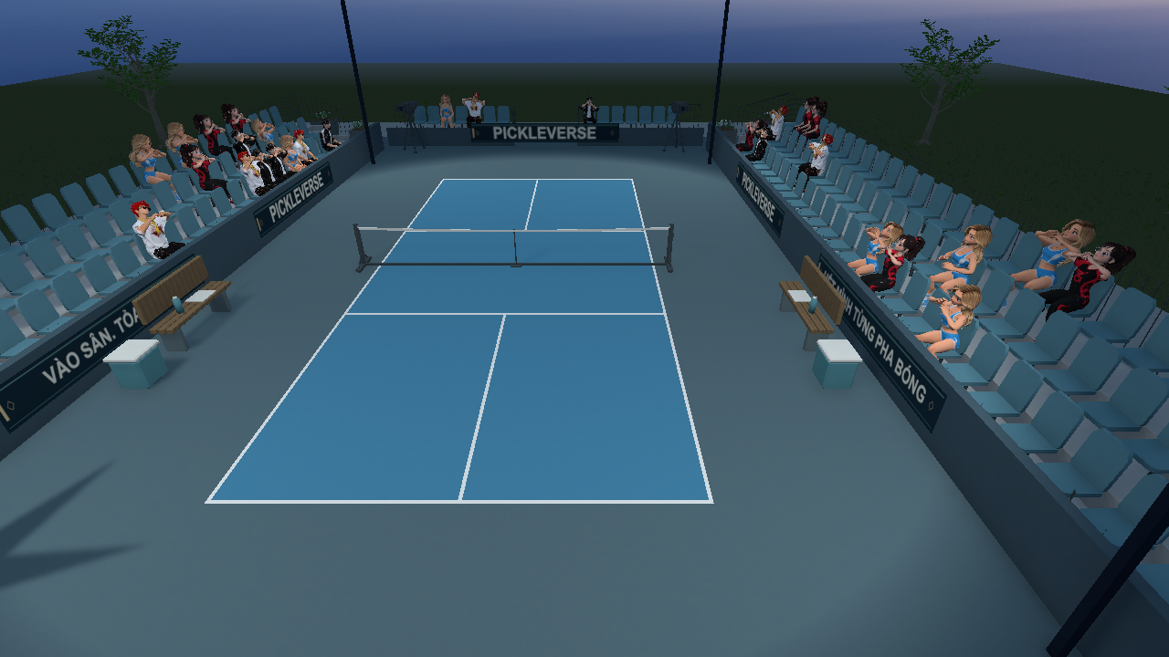
Figure 43. Multiplayer court scene
Function details
Business rules: BR-12 to BR-17, BR-28, BR-29.
Normal flow:
1. The court loads and the server starts the match after all players are connected.
2. Players play rallies; scores are shown from the server state.
3. The server ends the match and the result popup appears (FR-18).
Alternative and exception flows:
• E1 – Photon cannot be reached: MSG45.
• E2 – The connection to the match server is lost: MSG42 and FR-17 starts.

FR-17 Reconnect to or Leave a Match
Related use cases: UC-26 Reconnect to Match, UC-27 Leave Match
Function trigger: Connection loss during an online match; pause menu → leave.
Function description: If a player's connection drops, the client shows a reconnecting overlay and retries for up to 30 seconds with the same identity. The server keeps the player's slot for 35 seconds after the last heartbeat. A player who reconnects in time continues with the server score. A player who leaves, or who does not return in time, causes the match to end as interrupted; interrupted matches change no Elo and give no reward.
Screen layout
Table 17. FR-17 screen layout
Area | Elements and behaviour
Reconnecting overlay | Status text and countdown; the court stays visible in the background
Leave dialog | Warning about the consequence and Confirm / Cancel buttons

Function details
Business rules: BR-28, BR-29.
Normal flow:
1. The client detects the loss and starts reconnecting.
2. The player rejoins with the same ticket identity and control is restored.
Alternative and exception flows:
• E1 – Reconnection fails within 30 seconds: MSG43; the result is shown when the server finishes processing.
• A1 – The player confirms leaving: MSG44 and the Menu opens.

FR-18 Record the Match Result and Update Elo
Related use cases: UC-16, UC-25 (non-screen settlement)
Function trigger: End of a bot match (reported by the client) or of an online match (reported by the dedicated server).
Function description: The API settles each match exactly once in a single transaction: it stores the game scores, marks the match FINISHED, applies Elo for ranked matches, grants Tokenpad and XP, and updates missions, achievements and streaks. The result popup and the history (FR-24) show the outcome.
Screen layout
The layout is also shown in Figure 38.
Function details
Business rules: BR-22, BR-23, BR-29, BR-32 to BR-35.
Normal flow:
1. The API receives the result with the match identifier.
2. It validates that the match is still PLAYING and that the reporter is allowed to report it.
3. It saves scores, Elo, rewards and progress, then returns the summary to the clients.
Alternative and exception flows:
• A1 – The result is sent again: the stored result is returned and nothing is applied twice.
• E1 – The match was stopped by an administrator before the result: no Elo or reward (BR-48).

3.6 AI Coaching (FE-05)

FR-19 View Coaching Summary and Drill Recommendations
Related use cases: UC-17 View Coaching Summary, UC-18 View Drill Recommendation
Function trigger: Drill Result → analysis panel; Match Result → Xem phân tích.
Function description: The client uploads the shot telemetry of the drill or match (for online matches the dedicated server uploads it). The hybrid AI worker sends the session to the AI coaching service, which detects common errors with rules (for example late contact, dink too high, entering the non-volley zone after a volley), writes a short summary and recommends at most three drills. When the gated tier model is approved, it also estimates the player's tier. The coaching popup shows the counts of shots, contacts and serves, the main errors with their frequency, and the recommended drills.
Screen layout
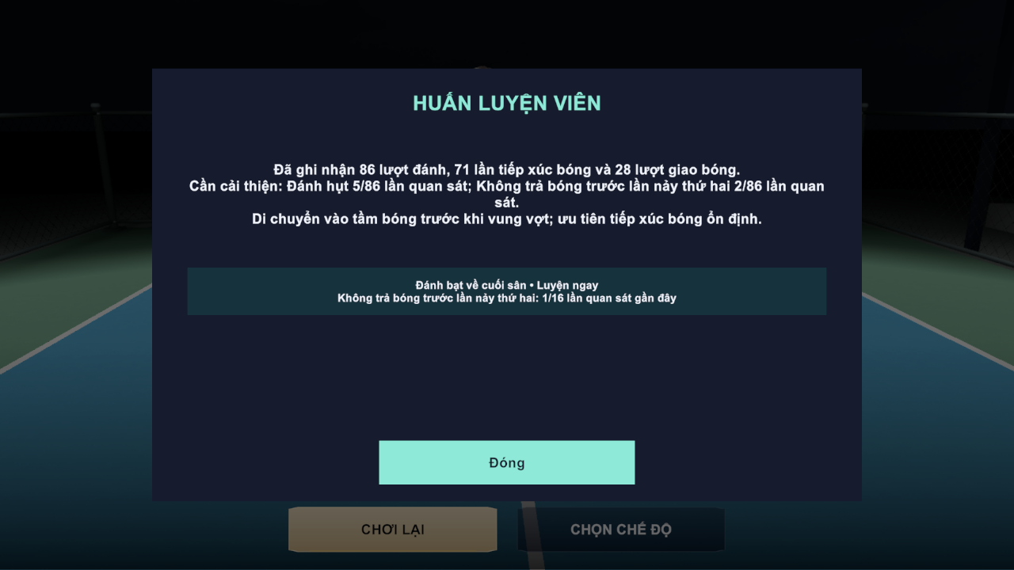
Figure 44. Coaching summary after a bot match
Function details
Business rules: BR-50, BR-51.
Normal flow:
1. The player opens the analysis; the client polls the analysis job.
2. The summary and recommendations appear when the job is completed.
3. Luyện ngay opens the recommended lesson briefing.
Alternative and exception flows:
• A1 – The analysis is still running: the panel shows "Đang phân tích…".
• E1 – Too few shot opportunities: no finding is reported for that error.
• E2 – AI service unavailable: the job is retried by the worker; the player can open the analysis later.

3.7 Progress, Rewards and Shop (FE-06)

FR-20 Earn Experience, Levels and Progression Rewards
Related use cases: UC-15, UC-16 (non-screen progression)
Function trigger: Settlement of a drill (FR-08) or match (FR-18); claiming mission rewards (FR-21).
Function description: Players earn XP from matches, lessons and missions. Reaching the XP threshold raises the level, which is shown in the name tag and history card. Two items are granted automatically once: the THOT paddle after 10 passed lessons and the GEMSTONE paddle at level 25.
Screen layout
The layout is also shown in Figure 25.
Function details
Business rules: BR-20, BR-32, BR-33, BR-37.
Normal flow:
1. XP is added by the settlement.
2. If XP reaches level × 200, the level increases and the remaining XP carries over.
3. Progression grants are checked and recorded in the reward log so that each is given once.

FR-21 Missions, Streak and Achievements
Related use cases: UC-37 to UC-40
Function trigger: Menu → Nhiệm vụ; Progress → Nhiệm vụ ngày / tuần.
Function description: Seven daily and ten weekly missions track matches, wins, points, valid returns and serves, bot matches and human matches. Completing all daily or weekly missions unlocks a set bonus. The daily streak counts consecutive days with at least one match. Ten achievements reward long-term goals such as 5, 25 and 100 wins.
Screen layout
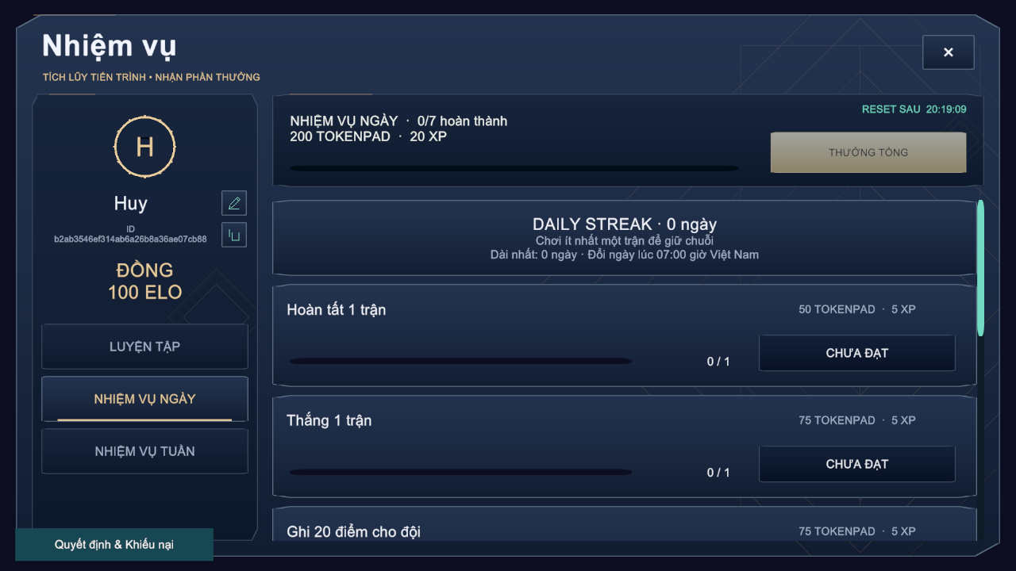
Figure 45. Missions popup with daily streak and reset countdown
Function details
Business rules: BR-34, BR-35.
Normal flow:
1. The player opens Missions; progress and the reset countdown are shown.
2. A completed mission shows NHẬN THƯỞNG (or NHẬN THƯỞNG TỔNG for the set bonus); the player claims it and the reward is added.
3. Achievement rewards are claimed in the same way (MSG49).
Alternative and exception flows:
• A1 – A reward is claimed twice: the second claim adds nothing.
• A2 – Missions renew at 07:00 Vietnam time; unclaimed progress of the old cycle is closed.

FR-22 Browse Shop and Purchase Cosmetic
Related use cases: UC-41 Browse Shop, UC-42 Purchase Cosmetic
Function trigger: Menu → Cửa hàng.
Function description: The shop lists cosmetic paddles with preview, description and price. An item can have a Tokenpad price, an Elite Token price or both. The purchase debits the wallet and adds the item to the collection in one transaction.
Screen layout
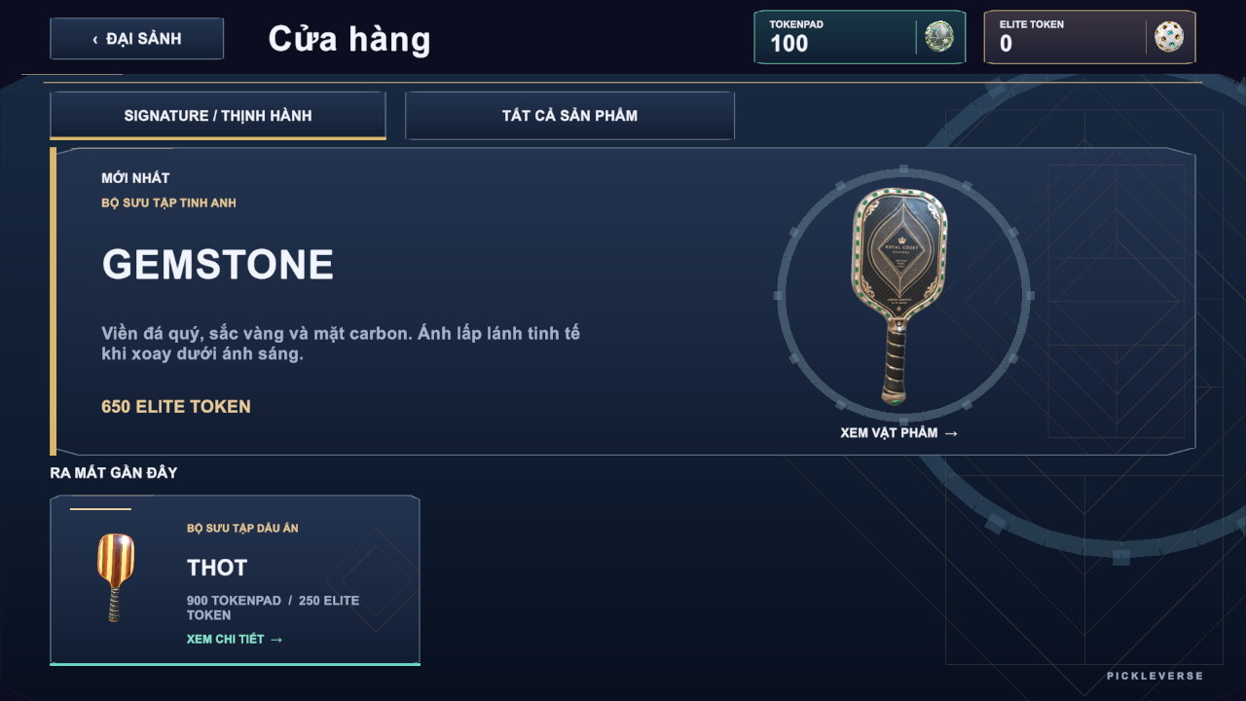
Figure 46. Shop with featured GEMSTONE and THOT paddles
Function details
Business rules: BR-36.
Normal flow:
1. The player selects an item and its currency and confirms the purchase.
2. The API checks ownership and balance, debits the price and grants the item.
3. The wallet and the collection are refreshed.
Alternative and exception flows:
• E1 – Not enough balance: MSG46.
• E2 – Item already owned: MSG47.
• E3 – Transaction failure: no balance is changed.

FR-23 View Collection and Equip Cosmetic
Related use cases: UC-43 View Collection, UC-44 Equip Cosmetic
Function trigger: Menu → Bộ sưu tập.
Function description: The collection shows all paddles with their status: in use, owned or not owned (preview only). The player equips an owned paddle, which is then used in matches and replays.
Screen layout
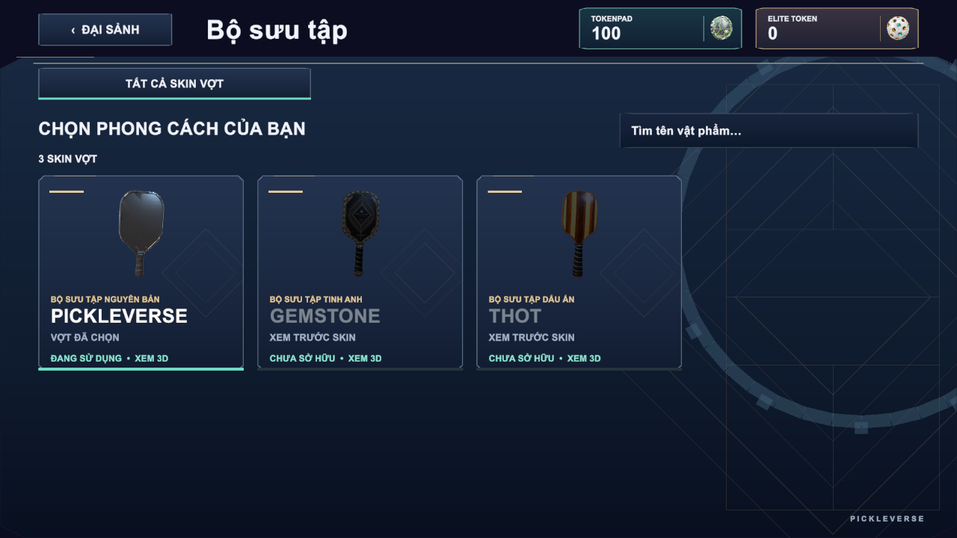
Figure 47. Collection of paddle skins
Function details
Business rules: BR-36.
Normal flow:
1. The player selects an owned paddle and TRANG BỊ.
2. The API marks it as the only equipped item; the menu character shows it.
Alternative and exception flows:
• E1 – The item is not owned: MSG48.

3.8 Social, History and Ranking (FE-07)

FR-24 View Match History and Watch Replay
Related use cases: UC-28 View Match History, UC-29 Watch Match Replay
Function trigger: Menu → Lịch sử; history entry → replay button.
Function description: The history popup lists the player's last 20 matches in Vietnam time with opponent, mode, result (win, loss or interrupted), game score and Elo change, plus the level card. A match with a stored replay can be watched in the Replay Viewer with pause, seek and speeds from 0.5× to 2×. Only participants can open a replay.
Screen layout
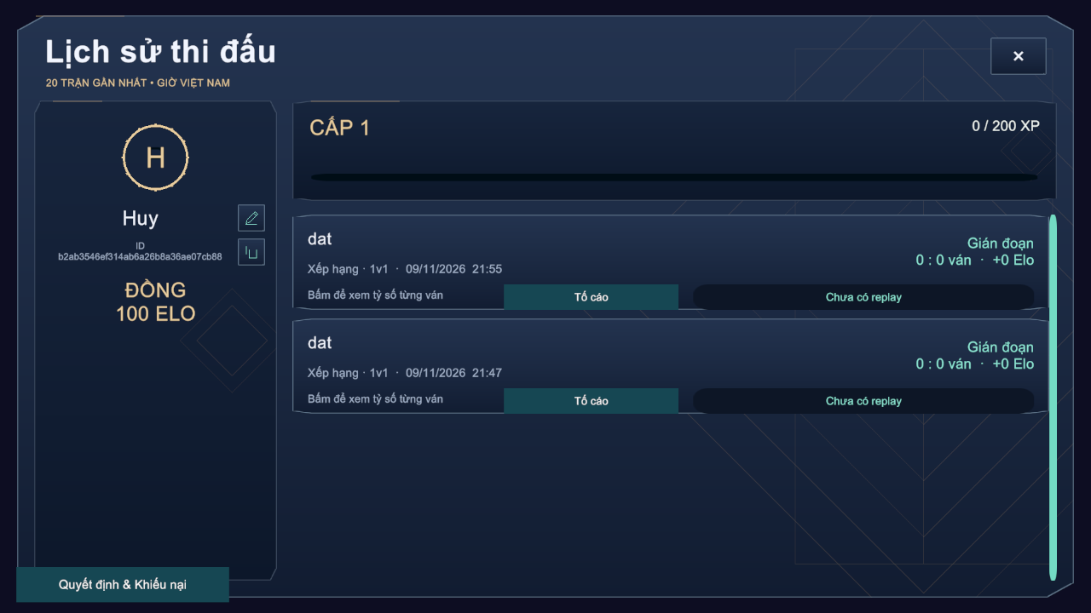
Figure 48. Match history with interrupted ranked matches
Function details
Business rules: BR-29, BR-40.
Normal flow:
1. The player opens History; the list loads from the API.
2. The player selects a replay; the manifest and chunks are downloaded and played.
Alternative and exception flows:
• A1 – No replay stored: the entry shows "Chưa có replay".
• E1 – A player who did not take part requests the replay: HTTP 403.

FR-25 Manage Friends and Blocked Players
Related use cases: UC-32 to UC-36
Function trigger: Menu → friend drawer → Bạn bè.
Function description: The player searches other players by name or ID, sends friend requests, accepts or declines received requests, removes friends and blocks or unblocks players. Online friends can be invited to a room (FR-15).
Screen layout
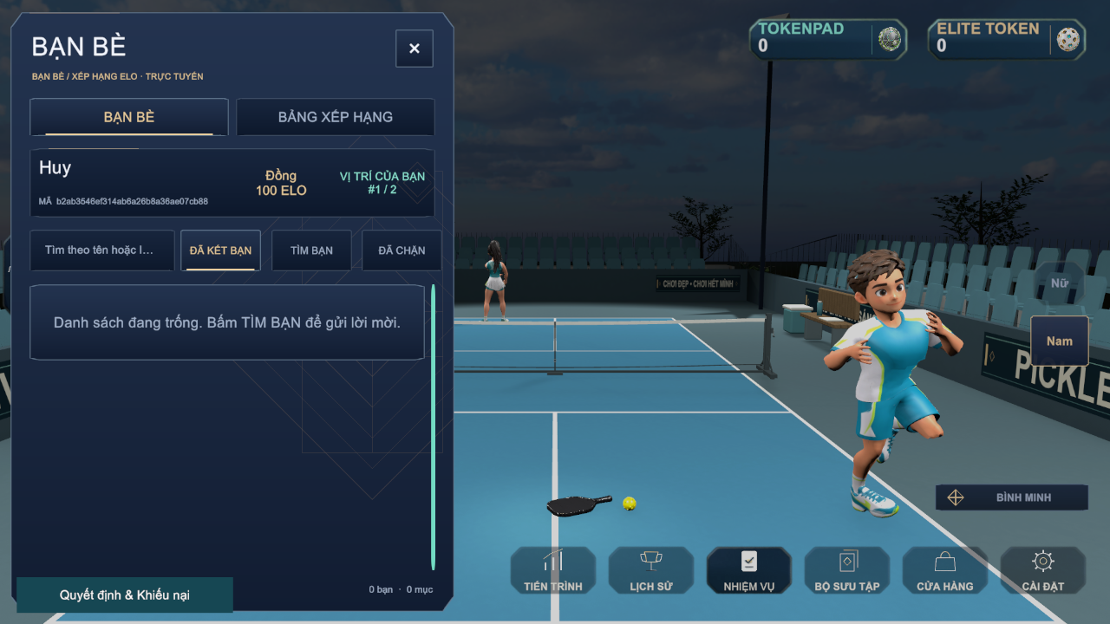
Figure 49. Friends drawer
Function details
Business rules: BR-38.
Normal flow:
1. The player searches by name or ID and sends a request.
2. The receiver accepts or declines it under the requests list.
3. The player can remove a friend or block a player from the list.
Alternative and exception flows:
• E1 – No match for the search: MSG51.
• E2 – The other player has already sent a request: MSG50.
• E3 – A request to oneself or to a blocked player is rejected.

FR-26 View Leaderboard
Related use cases: UC-31 View Leaderboard
Function trigger: Menu → friend drawer → Bảng xếp hạng.
Function description: The leaderboard lists players by Elo in descending order with rank tier, and highlights the player's own position, which can be located with Vị trí của tôi.
Screen layout
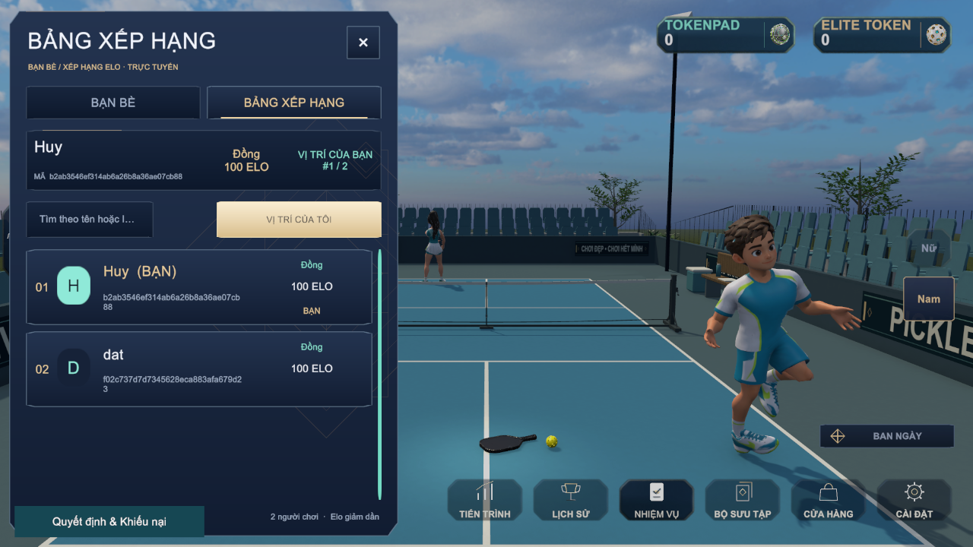
Figure 50. Elo leaderboard
Function details
Business rules: BR-27, BR-39.
Normal flow:
1. The player opens the leaderboard; the cached list is loaded.
2. The player searches by name or jumps to the own position.

3.9 Reports, Restrictions and Appeals (FE-08)

FR-27 Report a Player
Related use cases: UC-30 Report Player
Function trigger: Match History → Tố cáo on a finished match.
Function description: A player reports an opponent from one of their own matches with a reason. The report is stored as PENDING for administrators (FR-30).
Screen layout
The layout is also shown in Figure 48.
Function details
Table 18. FR-27 data fields
Field | Type | Required | Validation and constraints
Reported player | Choice | Yes | A participant of the match other than the reporter (MSG52)
Reason | Text (≤254) | Yes | Not empty

Business rules: BR-41, BR-44.
Normal flow:
1. The player selects Tố cáo, the opponent and enters the reason.
2. The API stores the report; the button changes to the reported state.
Alternative and exception flows:
• E1 – The player has already reported this player in this match: the duplicate is rejected.
• E2 – No eligible player: MSG52.

FR-28 View Sanction Decision and Submit Appeal
Related use cases: UC-45 View Sanction Decision, UC-46 Submit Appeal
Function trigger: Sign-in of a restricted account (automatic); Menu → Quyết định & Khiếu nại.
Function description: A restricted player sees each sanction with its type (suspended or banned), reason and expiry, and can submit one appeal per sanction. The appeal status (PENDING, CHECKING, ACCEPTED, DECLINED) and the administrator's decision reason are shown when available.
Screen layout
Table 19. FR-28 screen layout
Area | Elements and behaviour
Decision list | Restriction type, reason, start and expiry ("Không thời hạn" for an indefinite ban)
Appeal form | Statement field (10–4000 characters) and Send button; hidden when an appeal already exists
Appeal status | Status badge and decision reason

Function details
Table 20. FR-28 data fields
Field | Type | Required | Validation and constraints
Statement | Text | Yes | 10–4000 characters (MSG53)

Business rules: BR-42, BR-43, BR-44.
Normal flow:
1. The restricted player opens the popup and reads the decision.
2. The player writes the statement and sends it; the status becomes PENDING.
Alternative and exception flows:
• E1 – Statement shorter than 10 characters: MSG53.
• E2 – No sanction to appeal: MSG54.
• E3 – An appeal already exists for the sanction: the form is not shown.

3.10 Administration Web Application (FE-09)

FR-29 Admin Sign-in and User Management
Related use cases: UC-47 to UC-53
Function trigger: Browser → admin web URL → Login; sidebar → Quản lý người dùng (/users).
Function description: An administrator signs in with an Admin account; other roles are rejected. On the Users page the administrator searches and filters accounts, assigns the Player or Admin role, verifies an e-mail manually when delivery failed, applies or revokes a sanction with a reason, and resets selected progress groups of a player after previewing the impact. Every change is written to the audit log.
Screen layout
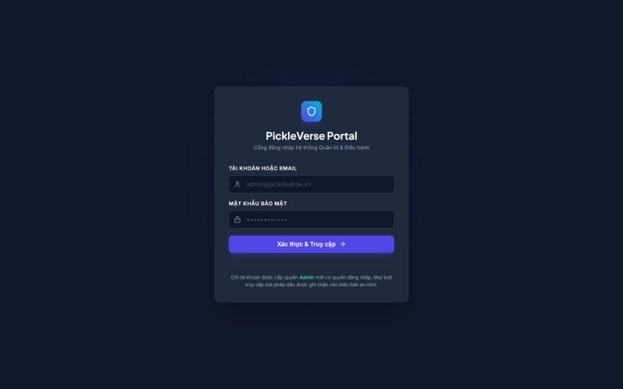
Figure 51. Admin web login page
Table 21. FR-29 screen layout
Area | Elements and behaviour
Header | Title "Quản lý Người dùng", search box (name, e-mail or ID) and status filter (all, ACTIVE, SUSPENDED, BANNED)
User table | Player and e-mail, role, status, Elo, play time, creation date and actions; paging
Role dialog | Player (game client only) or Admin (full portal access)
Sanction dialog | Suspend (expiry required) or ban (expiry optional) with a reason
Progress reset dialog | Groups LEARNING, RANKING, MISSIONS, ECONOMY, impact preview and Reset button

Function details
Table 22. FR-29 data fields
Field | Type | Required | Validation and constraints
Search text | Text | No | Matches name, e-mail or ID
Restriction | Choice | Yes (sanction) | SUSPENDED or BANNED
Expiry | Date-time (UTC) | Suspend: yes | Must be in the future (MSG56)
Reason | Text | Yes | 3–2000 characters (MSG55)
Reset groups | Multi-choice | Yes (reset) | At least one of LEARNING, RANKING, MISSIONS, ECONOMY

Business rules: BR-42, BR-45, BR-46.
Normal flow:
1. The administrator signs in and opens Users.
2. The administrator searches, selects an account and an action.
3. The administrator confirms; the API applies the change, writes the audit record and the table refreshes.
Alternative and exception flows:
• E1 – Non-admin account at login or on any admin API: HTTP 403.
• E2 – Sanction on the own account or a system account: MSG57.
• E3 – Reset while the player is searching or in a match: MSG58.
• E4 – Invalid reason or expiry: MSG55, MSG56.

FR-30 Review Player Reports and Appeals
Related use cases: UC-54 Review Player Report, UC-55 Review Appeal, UC-51 Apply Sanction
Function trigger: Sidebar → Xử lý vi phạm (/moderation).
Function description: The administrator opens a pending report, marks it CHECKING, examines the match evidence and replay, and accepts or declines it with a reason; accepting may apply a sanction to the reported player. Appeals are handled in the same way; accepting an appeal revokes only the sanction it concerns.
Screen layout
Table 23. FR-30 screen layout
Area | Elements and behaviour
Reports tab | Filter by status; reporter, reported player, match and evidence; Download match evidence and replay
Decision form | Outcome (accept or decline), optional sanction (suspend with expiry or ban) and decision reason; Save
Appeals tab | Statement, related sanction, decision (accept revokes only that sanction, decline keeps it) and reason

Function details
Table 24. FR-30 data fields
Field | Type | Required | Validation and constraints
Decision | Choice | Yes | ACCEPTED or DECLINED
Decision reason | Text | Yes | 3–2000 characters (MSG55)

Business rules: BR-42, BR-43, BR-44, BR-45.
Normal flow:
1. The administrator selects a report and reviews evidence.
2. The administrator enters the decision and reason and saves.
3. The report status changes; a sanction, if chosen, is applied and the player is restricted.
Alternative and exception flows:
• E1 – The report or appeal was changed by another administrator: the latest version is reloaded.
• E2 – A non-admin token: MSG63 (HTTP 403).

FR-31 Manage Training Content, Items and Missions
Related use cases: UC-56 to UC-61
Function trigger: Sidebar → Nội dung (CMS) (/cms).
Function description: The administrator creates and edits lessons as drafts, publishes a saved draft so that new attempts use it, and unpublishes a lesson to hide it from players; attempts already in progress keep their version. The administrator also maintains technique reference values, adds shop items and creates missions.
Screen layout
Table 25. FR-31 screen layout
Area | Elements and behaviour
Lesson manager | Lesson list; editor with code, name, group, order, target, prerequisite, coach text and technique template; Save draft, Publish saved version, Unpublish
Technique references | Reference values per technique with version; save requires the latest version
Shop item form | Item code, name, type (paddle, outfit, hat), price and currency
Mission form | Name, cycle (daily or weekly), target and reward

Function details
Table 26. FR-31 data fields
Field | Type | Required | Validation and constraints
Lesson code | Text | Yes | Unique (MSG59)
Target | Integer | Yes | 1 ≤ target ≤ number of shots
Prerequisite | Lesson | No | Must not create an unlock cycle
Price | Integer | Yes (item) | ≥ 0, with a currency

Business rules: BR-19, BR-45, BR-47.
Normal flow:
1. The administrator edits a lesson and selects Lưu bản nháp.
2. The administrator selects Xuất bản bản đã lưu; the lesson becomes PUBLISHED.
3. Gỡ xuất bản sets it to UNPUBLISHED.
Alternative and exception flows:
• E1 – Duplicate lesson code: MSG59.
• E2 – The content changed since it was loaded: MSG60.
• E3 – The prerequisite creates a cycle: the save is rejected.

FR-32 Monitor Matches and View Analytics
Related use cases: UC-62 to UC-66
Function trigger: Sidebar → Tổng quan (Dashboard), Giám sát trận đấu (/matches), Thống kê & AI Telemetry (/analytics).
Function description: The dashboard summarises today's activity and pending work. The Matches page shows live matches with the score and connection state reported by the dedicated server and lets the administrator stop a live match with a reason. The Analytics page reports daily active players, retention cohorts, popular lessons with pass rate (passes divided by started attempts), the technique-error heat map and matchmaking health for a chosen date range.
Screen layout
Table 27. FR-32 screen layout
Area | Elements and behaviour
Dashboard | Total users, daily active users, matches, online time, pending reports, technique-error heat map, Refresh
Matches | Live matches refreshed every 5 s with kind, players, score (games A : B) and connection; history list; Stop match dialog with reason and warning MSG61
Analytics | From/To dates (Vietnam time); daily players; retention cohorts; popular lessons with pass rate; error heat map; matchmaking health

Function details
Table 28. FR-32 data fields
Field | Type | Required | Validation and constraints
Stop reason | Text | Yes | 3–2000 characters
From / To date | Date | Yes | From ≤ To; at most 366 days (MSG62)

Business rules: BR-45, BR-48, BR-49.
Normal flow:
1. The administrator opens Matches; the list refreshes every 5 seconds.
2. To stop a match the administrator enters a reason and confirms MSG61; the server ends the match as interrupted.
3. The administrator opens Analytics, sets the dates and reads the reports.
Alternative and exception flows:
• E1 – The match already finished: the stop is ignored and the final result is kept.
• E2 – Invalid date range: MSG62.

3.11 Expert Review (FE-10)

FR-33 Review Coaching Sessions and Export Dataset
Related use cases: UC-67 Review Coaching Session, UC-68 Export Labelled Dataset
Function trigger: Sidebar → Gán nhãn coaching (/coaching).
Function description: An administrator acting as a pickleball expert inspects the shot-level evidence of a real training session, assigns the player level and confirms or rejects each error, and assigns the data group. All sessions of one player must use the same data group. The labelled sessions are exported to calibrate the rule thresholds and to evaluate the tier model against NFR-06.
Screen layout
Table 29. FR-33 screen layout
Area | Elements and behaviour
Session list | Synchronised real-player sessions with filters; simulated demo sessions are shown separately and read-only
Shot evidence | Per-shot telemetry (timing, contact, landing, net clearance) for the selected session
Labels | Player level (beginner, intermediate, advanced), error labels per code, data group (training, calibration, holdout), basis of the label; Save expert review

Function details
Table 30. FR-33 data fields
Field | Type | Required | Validation and constraints
Level | Choice | Yes | Beginner, intermediate or advanced
Error labels | Per error code | At least one | Present or absent with evidence (MSG64)
Data group | Choice | Yes | Training, calibration or holdout; consistent for a player

Business rules: BR-45, BR-50.
Normal flow:
1. The administrator selects a session and reviews the evidence.
2. The administrator sets the labels and saves the review.
3. The administrator exports the labelled dataset.
Alternative and exception flows:
• E1 – Missing confirmation, evidence or labels: MSG64.
• E2 – The session already has a newer review: the evidence must be reloaded.
• E3 – The player's sessions are in different data groups: HTTP 409.

4. Non-Functional Requirements

4.1 External Interfaces

4.1.1 User Interfaces
• The game interface is in Vietnamese with the project's Vietnamese fonts; it scales for 16:9 (1920×1080, 1280×720) and 20:9 phone screens; every screen can be operated with mouse and keyboard on PC and with touch on Android; Esc closes overlays and opens Settings, and Enter confirms.
• In-match information (score, serving side, timers, fault banners) is placed at the screen edges so that it does not cover the court.
• The administration web application is a responsive single-page application for desktop browsers with a fixed sidebar, tables with paging and confirmation dialogs for every destructive action.

4.1.2 Hardware Interfaces
• PC: keyboard and mouse; game controller input is not supported in release 1.0.
• Android: multi-touch screen for the virtual joystick and shot buttons.
• Server: Linux host with Docker; the dedicated game-server container is limited to 2 CPUs and 2 GB RAM by default.

4.1.3 Software Interfaces
Table 31. Software interfaces
Interface | Description
Web API (REST/JSON) | 122 endpoints under /api, JSON bodies wrapped in the ApiResponse<T> envelope {success, message, data}; error responses carry {success, message, code, errors}; JWT bearer authentication; Swagger/OpenAPI documentation
AI coaching service | Internal HTTP API POST /v1/analyze-session protected by the X-AI-Key header; called only by the Web API worker
Dedicated server ↔ Web API | HTTP calls for lease, heartbeat, telemetry, replay and result, authenticated with a service key; match tickets signed with HMAC-SHA256
Photon Fusion 2.1.3 | Real-time session service (protocol version 18) used by clients and the dedicated server
PostgreSQL 16 / Redis 7.4 | Persistent storage through Npgsql Entity Framework Core; Redis for matchmaking queue, leases, presence and caches
S3-compatible storage | Replay manifests and chunks through the S3 API

4.1.4 Communication Interfaces
• Client and admin web to Web API: HTTP/1.1 with JSON over TLS in production (port 443); the staging environment exposes HTTP on port 8080.
• Game traffic: UDP through Photon Cloud and to the dedicated server on UDP port 3669.
• E-mail: SMTP with STARTTLS on port 587 to Gmail.
• All timestamps are exchanged in UTC (ISO 8601) and displayed in Vietnam time (UTC+7).

4.2 Quality Attributes
Each quality attribute below is measurable and is verified by the test case named in the last column (Report 5).

4.2.1 Usability
Table 32. Usability requirements
ID | Requirement | Measure and acceptance criterion | Verification
NFR-01 | A new player can learn the game without outside help. | At least 8 of 10 first-time testers complete the 17-step tutorial in 5 minutes or less and then pass the first lesson (serve) within three attempts, without help from the team. | Moderated usability test with 10 students who have not played PickleVerse (Report 5, TC-N01)

4.2.2 Reliability
Table 33. Reliability requirements
ID | Requirement | Measure and acceptance criterion | Verification
NFR-07 | Online services are available when players want to play. | The API health endpoint /health/ready is available ≥ 99.5% of the time measured every 5 minutes by an external probe over the 14 days before the final defense (at most 100 minutes of downtime). | Uptime probe report (TC-N07)
NFR-08 | No result or reward is lost or duplicated. | Every match result, training receipt and purchase is applied exactly once under retries; after a container failure the service is restored from Docker Hub images within 1 hour (MTTR) with at most 24 hours of data loss from the daily database backup. No open Critical defect is allowed at release (Critical = loss of player data or inability to sign in or play). | Retry tests on settlement and sync APIs; restore drill (TC-N08)
NFR-11 | Training is possible without a connection. | After one online sign-in, all published lessons can be practised offline, and 100% of offline attempts are synchronised exactly once (no duplicate reward) when the device reconnects. | Offline–online test with 20 queued attempts (TC-N11)

4.2.3 Performance
Table 34. Performance requirements
ID | Requirement | Measure and acceptance criterion | Verification
NFR-02 | Online play is responsive for players in Vietnam. | Round-trip time between the client and the staging game server is at most 100 ms at the 95th percentile over 10 online matches on home broadband in Ho Chi Minh City. | Fusion RTT statistics logged by the client (TC-N02)
NFR-03 | Matches are smooth on mid-range devices. | Average frame rate ≥ 60 FPS (1% low ≥ 45 FPS) during a bot match on a reference PC (Intel Core i5 10th generation, GTX 1650, 16 GB RAM, 1920×1080, default quality); average ≥ 30 FPS on a reference Android phone (Snapdragon 7-series, 6 GB RAM). | Unity Profiler capture of a full bot match on each device (TC-N03)
NFR-04 | The Web API supports the target player population. | With 2,000 concurrent virtual users performing a read-mostly mix (profile, missions, leaderboard, history, catalogue) the API keeps the 95th-percentile response time ≤ 500 ms and the error rate < 1% for 10 minutes. The release capacity of online matches equals the number of dedicated server slots (one in the staging deployment, LI-07 in Report 1). | k6 load test against staging (TC-N04)
NFR-05 | Coaching feedback arrives quickly. | The AI coaching service returns the analysis of one drill or match in ≤ 1 second at the 95th percentile once the telemetry has been received; the coaching popup shows the result within 5 seconds of the end of the drill when online. | Timing of 50 analysis requests from the worker log (TC-N05)

4.2.4 Accuracy of AI Coaching
Table 35. Accuracy of AI Coaching requirements
ID | Requirement | Measure and acceptance criterion | Verification
NFR-06 | Coaching findings are trustworthy. | Each rule-based finding reaches precision ≥ 0.80 and recall ≥ 0.70 on the expert-labelled holdout sessions. The tier model is shown to players only when it is approved: real expert data, at least 10 holdout players per tier, macro-F1 ≥ 0.70 and at least 0.05 above the majority baseline, prediction confidence ≥ 0.65 and at least 20 shot opportunities. | Calibration and training reports of the AI service (TC-N06)

4.2.5 Security
Table 36. Security requirements
ID | Requirement | Measure and acceptance criterion | Verification
NFR-09 | Accounts and match results are protected. | Passwords are stored with BCrypt; access tokens are signed JWTs valid for 2 hours and refresh tokens are stored as SHA-256 hashes; OTPs and dedicated-server tickets are protected with HMAC; authentication endpoints are rate-limited; every admin endpoint requires the Admin role; secrets are supplied by environment variables and never committed; production traffic uses HTTPS (TLS 1.2+); match outcomes are decided only by the dedicated server. | Security checklist, API negative tests and secret scan (TC-N09)

4.2.6 Compatibility
Table 37. Compatibility requirements
ID | Requirement | Measure and acceptance criterion | Verification
NFR-10 | The game runs on the target platforms. | The client runs on Windows 10/11 64-bit and on Android 8.0 (API 26) or later on ARM64, at 16:9 and 20:9 aspect ratios with keyboard or touch input; the admin web supports the latest Chrome and Edge at 1366×768 or larger. | Installation and smoke test on each platform (TC-N10)

4.2.7 Maintainability and Privacy
Table 38. Maintainability and Privacy requirements
ID | Requirement | Measure and acceptance criterion | Verification
NFR-12 | The system can be changed safely and protects personal data. | The backend keeps the layered dependency rule (API → Services → Repositories → Entities) with no reverse reference; core rule classes are covered by automated unit tests that run before release; other players can see only the display name, player ID, rank and Elo, never the e-mail address, which is visible only to administrators. | Architecture check of project references, test run report and API response review (TC-N12)

5. Requirement Appendix

5.1 Business Rules
Table 39. Business rules
ID | Group | Rule Definition
BR-01 | Account | An e-mail address can be used by only one account.
BR-02 | Account | A password has 6 to 128 characters and is stored only as a BCrypt hash.
BR-03 | Account | A verification or reset code has six digits, is valid for 10 minutes, can be re-sent only after 60 seconds and allows at most 5 wrong attempts.
BR-04 | Account | Only an account with a verified e-mail can sign in. System bot accounts can never sign in. A suspended or banned account can sign in only with the appeal scope.
BR-05 | Account | An access token is valid for 2 hours and a refresh token for 14 days; a refresh token is replaced each time it is used. Resetting the password or signing out revokes the refresh tokens concerned.
BR-06 | Account | A display name has 3 to 18 characters, contains no control characters and is unique among players.
BR-07 | Account | The experience level (Beginner or Experienced) is chosen once, at the first sign-in.
BR-08 | Account | The display name and character cannot be changed while the player is in a room, searching for a match or playing a match.
BR-09 | Gameplay | The court is 13.41 m × 6.10 m; the non-volley zone extends 2.13 m from the net on each side. A ball touching a line is in.
BR-10 | Gameplay | A singles match is the best of three games. A game is won by the first side to reach 11 points with a lead of at least 2. Only the serving side scores a point; a fault by the server gives the serve to the opponent (side-out).
BR-11 | Gameplay | The serve is hit underhand, with both feet behind the baseline, into the diagonal service court and beyond the non-volley zone, within 10 seconds after the server is ready. The server serves from the right court when the server's score is even and from the left when it is odd.
BR-12 | Gameplay | Two-bounce rule: the return of serve and the third shot must bounce once before they are hit.
BR-13 | Gameplay | A volley may not be hit while standing in the non-volley zone, and the player's momentum after a volley may not carry them into the zone.
BR-14 | Gameplay | The rally ends with a fault of one of 17 types: serve foot, serve motion, serve timeout, short serve, serve to the wrong court, missed serve, out, ball into own court, two-bounce rule, double bounce, double hit, kitchen volley, kitchen momentum, net touch, body hit, net plane and permanent object.
BR-15 | Gameplay | Each side has two time-outs per game. In the third game the players change ends when a side first reaches 6 points.
BR-16 | Gameplay | A paddle contact is accepted only when the key is released within ±65 ms of the ideal contact time. A contact is Perfect when the contact error is ≤ 0.145 m and the timing error is within ±30 ms.
BR-17 | Gameplay | Shot keys: J drive (and serve), K dink, L volley, J+K drop, J+L smash, K+L reset; U adds power and I aims cross-court. The shot is decided once, when the first base key is released.
BR-18 | Training | Drill score: 0 stars below the target; 1 star when the target is reached; 2 stars at ≥ 80% hits; 3 stars at ≥ 90% hits with a mean timing error ≤ 0.16 s. The best result of each lesson is kept.
BR-19 | Training | A lesson is unlocked when its prerequisite lesson has been passed; a locked lesson cannot be started. Prerequisites cannot form a cycle.
BR-20 | Training | The first pass of a lesson grants 150, 225, 300 or 450 Tokenpad and 5, 7, 10 or 15 XP according to the lesson group; later passes and failed attempts grant no currency and cost nothing.
BR-21 | Training | Offline training is allowed only for a profile cached by a previous online sign-in. Each attempt carries a unique request ID and is applied at most once (receipt APPLIED, DUPLICATE or REJECTED).
BR-22 | Match | Match kinds are Bot Practice, Ranked Bot, Ranked Singles, Matched Doubles and Custom. Only Ranked Singles and Ranked Bot change Elo.
BR-23 | Match | A new player starts at 100 Elo, which is also the minimum. After a ranked match Elo changes by round(32 × (S − E)), where S is 1 for a win and 0 for a loss and E = 1 / (1 + 10^((R_opponent − R_own)/400)); the result is never below 100.
BR-24 | Match | Ranked pairing uses a window of 120 Elo. During the first 30 seconds the window extends only upward (only downward for a player with 5 or more losses); after 30 seconds it extends 120 in both directions.
BR-25 | Match | When a match is found, every player must accept within 10 seconds; a decline or a timeout cancels the offer.
BR-26 | Match | If no human opponent is found within 180 seconds, a ranked bot is assigned with Elo = own + 120 (own − 100 for a player with 5 or more losses).
BR-27 | Match | Rank tiers by Elo: Đồng < 500, Bạc < 1000, Vàng < 2000, Bạch Kim < 3500, Kim Cương < 5000, Cao Thủ < 7000, Huyền Thoại ≥ 7000.
BR-28 | Match | A disconnected client tries to reconnect for 30 seconds. The dedicated server sends a heartbeat every 8 seconds and the API keeps the player's slot for 35 seconds after the last heartbeat; after that the match is interrupted.
BR-29 | Match | A match result is saved exactly once. An interrupted or stopped match gives no Elo and no reward.
BR-30 | Match | A singles room holds 2 players and a doubles room up to 4. The host starts a custom match and may start a doubles room before all four slots are filled; custom matches are unrated.
BR-31 | Match | Bot levels Easy, Medium and Hard use fixed reaction, accuracy and error settings. The adaptive bot selects its tier from the player's Elo: below 500 beginner, below 2000 intermediate, otherwise advanced.
BR-32 | Economy | Match rewards: bot match win 100 / loss 50 Tokenpad; online match win 150 / loss 75 Tokenpad; every finished match gives 10 XP for a win and 5 XP for a loss.
BR-33 | Economy | Reaching level n+1 requires n × 200 XP at level n; surplus XP carries over.
BR-34 | Economy | There are 7 daily and 10 weekly missions. Daily missions renew at 07:00 Vietnam time (UTC+7) and weekly missions at the start of each mission week. Completing all daily missions gives 200 Tokenpad + 20 XP and all weekly missions 1,000 Tokenpad + 50 XP. The daily streak grows by one for each day with at least one finished match.
BR-35 | Economy | Each mission, mission set and achievement reward can be claimed only once.
BR-36 | Economy | A purchase requires enough balance in the chosen currency and is refused if the item is already owned; the debit and the grant are one transaction. Exactly one paddle is equipped at a time. Elite Token has no earning source in release 1.0.
BR-37 | Economy | The THOT paddle is granted once after 10 passed lessons and the GEMSTONE paddle once at level 25, unless already owned.
BR-38 | Social | A player cannot send a friend request to themself, send a duplicate request, or send one to a player who has already sent them a request. Blocking removes the friendship and prevents friend requests and room invitations in both directions.
BR-39 | Social | The leaderboard is ordered by Elo descending and is cached for 15 seconds.
BR-40 | Social | A match history and its replay can be read only by the players who took part and by administrators.
BR-41 | Moderation | A player can report another participant of their own finished match once per match; self-reporting is not allowed; the reason has at most 254 characters.
BR-42 | Moderation | A sanction is SUSPENDED (expiry required and in the future) or BANNED (expiry optional). The reason has 3 to 2,000 characters. An administrator cannot sanction their own account or a system account. An expired suspension ends automatically.
BR-43 | Moderation | A restricted player can submit one appeal per sanction, with a statement of 10 to 4,000 characters. Accepting an appeal revokes only the sanction it concerns.
BR-44 | Moderation | Reports and appeals move from PENDING to CHECKING to ACCEPTED or DECLINED; a decision requires a reason.
BR-45 | Administration | Only the Admin role can use the administration application and API (otherwise HTTP 403). Every administrative change is recorded in the audit log with actor, action, target and time.
BR-46 | Administration | Progress reset works on the groups LEARNING, RANKING, MISSIONS and ECONOMY after an impact preview, and is refused while the player is searching or in a match. It keeps the account, friends, match history, decisions and reward log; rewards already granted are not granted again.
BR-47 | Administration | A lesson moves DRAFT → PUBLISHED → UNPUBLISHED (and can be published again). Publishing applies to new attempts only. A save is refused when the content changed after it was loaded.
BR-48 | Administration | Stopping a live match requires a reason; when the stop is recorded before the final result the match is interrupted without Elo or reward.
BR-49 | Administration | Analytics dates are calendar days in Vietnam time; the start date is not after the end date and a range covers at most 366 days.
BR-50 | AI coaching | A coaching finding is reported only when the session contains at least 5 opportunities for that error; at most 3 drills are recommended; the tier estimate is shown only under the approval conditions of NFR-06.
BR-51 | AI coaching | Telemetry and replays of dedicated-server matches are submitted only by the dedicated server; a client can submit telemetry only for its own drills and bot matches.

5.2 Common Requirements
• Language: all player-facing and administrator-facing text is Vietnamese; documents and source code identifiers are English.
• Date and time: stored in UTC and shown in Vietnam time (dd/MM/yyyy HH:mm); daily cycles (missions, streaks, analytics days) start at 07:00 or 00:00 Vietnam time as stated in the related rule.
• API responses: every JSON response uses the ApiResponse envelope; HTTP 400 validation, 401 not signed in, 403 forbidden, 404 not found, 409 conflict, 429 too many requests, 503 dependency unavailable; HTTP 500 responses never expose internal details.
• Idempotency: commands that change progress, wallet or match state carry a client request ID; repeating a request returns the first result.
• Concurrency: administrative edits use a version check and ask the user to reload when the data changed.
• Lists: account lists are paged (20 rows per page by default in the API); the game history shows the last 20 matches.
• Logging: the API, workers and dedicated server write structured logs without passwords, tokens or codes.

5.3 Application Messages List
Table 40. Application messages
# | Message code | Message Type | Context | Content
1 | MSG01 | In red, under the text box | E-mail field is empty | Vui lòng nhập email.
2 | MSG02 | In red, under the text box | E-mail format is invalid | Vui lòng nhập địa chỉ email hợp lệ.
3 | MSG03 | In red, under the text box | Password field is empty | Vui lòng nhập mật khẩu.
4 | MSG04 | In red, under the text box | Password shorter than 6 characters | Mật khẩu cần ít nhất 6 ký tự.
5 | MSG05 | In red, under the text box | Confirmation differs from the password | Mật khẩu xác nhận chưa khớp.
6 | MSG06 | In red, under the form | E-mail already registered | Email đã được đăng ký. Nếu chưa xác thực, hãy dùng chức năng gửi lại mã.
7 | MSG07 | In line, information | Registration succeeded | Đã đăng ký. Hãy nhập mã được gửi tới email để kích hoạt tài khoản.
8 | MSG08 | In red, under the text box | Code is not six digits | Mã xác thực gồm 6 chữ số.
9 | MSG09 | In line, information | A new code was sent | Mã xác thực đã được gửi. Hãy kiểm tra cả thư rác.
10 | MSG10 | In red, under the form | Code re-sent within 60 seconds (HTTP 429) | Vui lòng chờ ít nhất 60 giây trước khi gửi lại mã.
11 | MSG11 | In red, under the form | Sign-in with an unverified e-mail | Email chưa được xác thực. Hãy nhập OTP hoặc yêu cầu gửi lại mã.
12 | MSG12 | In red, under the form | Wrong e-mail or password | Email hoặc mật khẩu không chính xác.
13 | MSG13 | Toast message | Sign-in succeeded | Đăng nhập thành công.
14 | MSG14 | Popup | Sign-in of a suspended or banned account | Tài khoản đang bị hạn chế. Bạn có thể xem quyết định và gửi khiếu nại.
15 | MSG15 | In line, information | Password reset requested (same text whether or not the e-mail exists) | Nếu email thuộc tài khoản đã xác thực, mã đặt lại mật khẩu sẽ được gửi. Hãy kiểm tra cả thư rác.
16 | MSG16 | In red, under the form | Reset code wrong or expired | Mã đặt lại mật khẩu không hợp lệ hoặc đã hết hạn.
17 | MSG17 | In red, under the form | Password rule rejected by the API | Mật khẩu cần từ 6 đến 128 ký tự và xác nhận phải khớp.
18 | MSG18 | Popup | Refresh token expired or revoked | Phiên đăng nhập không hợp lệ hoặc đã hết hạn.
19 | MSG19 | In red, under the text box | Display name length invalid | Tên người chơi cần từ 3 đến 18 ký tự.
20 | MSG20 | In red, under the text box | Display name already used | Tên người chơi đã được sử dụng. Hãy chọn tên khác.
21 | MSG21 | Popup question | First sign-in experience choice | Bạn đã quen với pickleball chưa? – Người mới sẽ được hướng dẫn luật và điều khiển. Nếu đã thành thạo, bạn có thể vào sảnh ngay.
22 | MSG22 | In red, under the form | Verification e-mail could not be sent | Chưa gửi được email xác thực. Vui lòng thử gửi lại mã sau ít nhất 60 giây.
23 | MSG23 | In line | Starting a locked lesson | Bài tập chưa mở khóa.
24 | MSG24 | Popup title | Drill target not reached | CHƯA ĐẠT MỤC TIÊU
25 | MSG25 | In line | Drill failed | Không mất Tokenpad. Luyện lại để đạt {target} cú.
26 | MSG26 | HUD feedback | Key released late | Bạn thả nút hơi muộn. Hãy chuẩn bị vợt và thả nút sớm hơn.
27 | MSG27 | HUD feedback | Key released early | Bạn thả nút hơi sớm. Hãy đợi bóng tiến gần hơn.
28 | MSG28 | Banner | Offline training mode | Đang luyện tập ngoại tuyến · {n} mục chờ đồng bộ
29 | MSG29 | HUD banner | Serve timer expired | Bạn đã hết 10 giây giao bóng. Hãy chuẩn bị và giao bóng trước khi hết thời gian.
30 | MSG30 | HUD banner | Rally ended by a fault (examples) | Lỗi • Bóng ra ngoài / Lỗi • Nảy hai lần / Lỗi • Vô lê trong vùng cấm vô lê / Lỗi • Bóng không qua lưới / Lỗi chân giao bóng
31 | MSG31 | Result title | Player wins the match | Bạn thắng trận!
32 | MSG32 | In line | Searching for an opponent | Đang tìm đối thủ trực tuyến…
33 | MSG33 | Popup | Match found, ready check | Đã tìm thấy trận • Xác nhận để tham gia.
34 | MSG34 | In line | Search expired | Hết thời gian tìm trận. Hãy thử lại.
35 | MSG35 | In line | Player declined the match | Bạn đã hủy tham gia. Bấm Tìm trận để tìm lại.
36 | MSG36 | In line | Dedicated server slot is busy | Máy chủ đang bận • Đang chờ lượt thi đấu…
37 | MSG37 | In line | Room is full | Phòng đã đủ người.
38 | MSG38 | In line | Room closed or player removed | Phòng đã đóng hoặc bạn đã được mời ra.
39 | MSG39 | In line | Joining a room failed (for example wrong code) | Không tham gia được phòng. Vui lòng thử lại.
40 | MSG40 | In line | Invited player cannot receive invitations | Người chơi chưa sẵn sàng nhận lời mời.
41 | MSG41 | In line | Player already searching or in an unfinished match | Người chơi đang tìm trận hoặc có trận chưa hoàn tất.
42 | MSG42 | Overlay | Connection to the match server lost | Mất kết nối máy chủ thi đấu.
43 | MSG43 | Popup | Reconnection failed | Không thể kết nối lại trận. Kết quả sẽ được cập nhật khi máy chủ xử lý xong.
44 | MSG44 | Toast message | Player left the match | Bạn đã rời trận.
45 | MSG45 | Popup | Photon Cloud not reachable | Không kết nối được Photon. Vui lòng kiểm tra mạng và thử lại.
46 | MSG46 | Popup | Balance too low for a purchase | Số dư tiền tệ không đủ để mua vật phẩm này.
47 | MSG47 | Popup | Item already owned | Bạn đã sở hữu vật phẩm này rồi.
48 | MSG48 | Popup | Equipping an item that is not owned | Bạn chưa sở hữu vật phẩm này.
49 | MSG49 | Toast message | Achievement reward claimed | Mở khóa thành công danh hiệu và phần thưởng: {reward}!
50 | MSG50 | In line | The other player already sent a request | Người chơi đã gửi lời mời cho bạn. Hãy chấp nhận hoặc từ chối.
51 | MSG51 | In line | No search result | Không tìm thấy tên hoặc ID phù hợp.
52 | MSG52 | In line | No player can be reported | Không có người chơi phù hợp để tố cáo
53 | MSG53 | In red, under the text box | Appeal statement too short | Nội dung khiếu nại cần ít nhất 10 ký tự.
54 | MSG54 | In line | No decision to appeal | Không có quyết định xử lý để khiếu nại.
55 | MSG55 | In red, under the text box | Reason length invalid (admin) | Lý do phải có từ 3 đến {max} ký tự.
56 | MSG56 | In red, under the text box | Suspension without a future expiry | Tạm ngưng cần thời hạn trong tương lai; khóa có thể không có thời hạn.
57 | MSG57 | Toast message | Admin tries to sanction own account | Không thể tự khóa tài khoản quản trị.
58 | MSG58 | In line, in the dialog | Reset while player searching or in a match | Người chơi đang tìm trận hoặc có trận chưa hoàn tất. Chưa thể reset.
59 | MSG59 | In red, under the text box | Lesson code already exists | Mã bài học đã tồn tại.
60 | MSG60 | Toast message | Content changed since it was loaded | Nội dung đã thay đổi. Hãy tải lại trước khi lưu.
61 | MSG61 | Warning in the dialog | Confirming a match stop | Trận sẽ bị gián đoạn và không tính Elo/thưởng nếu lệnh dừng được ghi trước kết quả cuối.
62 | MSG62 | In red, under the date fields | Invalid analytics range | Khoảng ngày thống kê không hợp lệ. / Biểu đồ hỗ trợ tối đa 366 ngày mỗi lần xem.
63 | MSG63 | Toast message | Non-admin calls a moderation function (HTTP 403) | Bạn không có quyền xử lý vi phạm.
64 | MSG64 | In red, under the form | Expert review incomplete | Hãy xác nhận phiên người thật, người đánh giá, bằng chứng và ít nhất một nhãn.
65 | MSG65 | In red, under the form | System account sign-in attempt | Tài khoản hệ thống không được đăng nhập.

5.4 Definitions and Acronyms
Table 41. Definitions and acronyms
Term | Definition
Dink | A soft shot that drops into the opponent's non-volley zone
Drill | A practice exercise with a fixed number of shots and a target
Elo | A rating system in which the rating change depends on the expected result against the opponent
Kitchen / NVZ | Non-volley zone: the area within 2.13 m of the net where volleys are not allowed
Rally | The exchange of shots from the serve until a fault
Side-out | Loss of serve to the opponent after a fault by the serving side
Telemetry | Shot-level data (timing, contact, landing, position) recorded by the game
Tokenpad / Elite Token | In-game currencies; Tokenpad is earned by playing
Dedicated server | A headless Unity server that runs an online match with authority over the result
Photon Fusion | Third-party networking library and cloud used for real-time sessions
API, JWT, OTP, HMAC | Application programming interface; JSON Web Token; one-time password; hash-based message authentication code
BR, FR, NFR, UC, MSG | Business rule; functional requirement; non-functional requirement; use case; message

5.5 Appendix A – Traceability to the Review 2 Commitment
Table below links the 18 features committed in the Review 2 form BM04 to the use cases and functional requirements of this specification. Report 5 links each requirement to its test cases.
Table 42. Traceability from Review 2 features to requirements
Review 2 feature | Name | Functional requirements | Use cases
F01 | Account and first steps | FR-01, FR-02, FR-03, FR-04 | UC-01 to UC-08
F02 | Rules and controls | FR-05, FR-06, FR-11 | UC-09, UC-10
F03 | Guided drills | FR-07, FR-08 | UC-11, UC-12
F04 | Levels and items | FR-20, FR-23 | UC-43, UC-44
F05 | Adaptive bot | FR-12, FR-13 | UC-16
F06 | Coaching and tier | FR-19 | UC-17, UC-18
F07 | Quick match | FR-14 | UC-19, UC-20
F08 | Private rooms | FR-15 | UC-21 to UC-24
F09 | Dedicated play | FR-16, FR-17 | UC-25 to UC-27
F10 | Result and Elo | FR-18 | UC-25
F11 | Progress and replay | FR-10, FR-24 | UC-15, UC-28, UC-29
F12 | Friends and ranks | FR-25, FR-26 | UC-31 to UC-36
F13 | Daily and streak rewards | FR-21 | UC-37 to UC-40
F14 | Offline practice | FR-09 | UC-13, UC-14
F15 | Admin and accounts | FR-29 | UC-47 to UC-53
F16 | Lesson publishing | FR-31 | UC-56 to UC-61
F17 | Match care and reports | FR-27, FR-28, FR-30, FR-32 | UC-30, UC-45, UC-46, UC-54, UC-55, UC-62 to UC-64
F18 | Admin charts | FR-32 | UC-65, UC-66
– | Shop (not in the Review 2 list) | FR-22 | UC-41, UC-42
– | Expert review (addition to the proposal) | FR-33 | UC-67, UC-68

5.6 References
[1] USA Pickleball, "Official Rulebook 2024." https://usapickleball.org/what-is-pickleball/official-rules/ (accessed 11 Nov. 2026).
[2] K. E. Wiegers and J. Beatty, Software Requirements, 3rd ed. Microsoft Press, 2013.
[3] Photon Engine, "Fusion 2 Documentation." https://doc.photonengine.com/fusion/current (accessed 11 Nov. 2026).
[4] GFA26SE111, "Report 1 – Project Introduction" and "Report 4 – Software Design Document," PickleVerse, 2026.

